Runoff and sediment storage: the effectiveness of mitigation measures against soil erosion and freshwater pollution

J. Boardman^{1*} and I.D.L. Foster²

¹Environmental Change Institute, Oxford Centre for the Environment, University of Oxford, South Parks Road, Oxford OX1 3QY, UK & Department of Geography, University of the Free State, PO Box 339, Bloemfontein, 9300, South Africa
²Department of Environmental and Geographical Sciences, FAST, Learning Hub, Northampton University, Northampton, NN1 5PH, UK & Department of Geography, Rhodes University, Eastern Cape, South Africa
*corresponding author Email: john.boardman@eci.ox.ac.uk

Abstract

Measures such as detention structures and buffer strips are widely used to limit off-site damage of runoff from eroding fields. The effectiveness of such measures varies greatly. However, ‘effectiveness’ is often narrowly defined and ignores the unintended consequences of damage to freshwater systems by sediments and other pollutants. Detention structures and buffer strips retain coarse sediment (>~100 µm diameter) but are less effective at retaining fine sediment.

Keywords: mitigation measures, river pollution, buffer strips, detention structures, pollution swapping, soil erosion

Introduction: what do we know about ‘effectiveness’?

When we discuss ‘effectiveness’ we need to be clear about what the measure is effective against. Measures may effectively control the loss of soil on a field. These will include minimum tillage, cover crops, coarse tilths. Other measures, such as buffer strips and retention banks will aim to reduce the loss of soil from a field to off-site locations. A change of land use may reduce or eliminate erosion and runoff e.g. a change from arable to grassland.
Mitigation measures are more successful at controlling soil erosion than they are at limiting runoff. This is true globally (Xiong et al., 2018) with similar conclusions from Europe (Maetens et al., 2012). However, even well-thought-through schemes are not always successful (Raike et al., 2020).
The great range in effectiveness of mitigation measures is emphasised by Rickson (2014, Figure 2) with mean values for 18 measures generally ranging from ca 50 to 100 %.
Effectiveness is defined as, ‘the amount by which a mitigation measure may reduce diffuse pollution losses compared to a baseline or absolute soil loss where no mitigation was used’ (Rickson, 2014 p. 1191).
Controlling erosion does not necessarily lead to protection of watercourses: successful mitigation involves the cooperation of many land managers in a catchment rather than the installation of individual measures on single farms. In Flanders, measurable declines in

sediment output have been achieved, with many sites of buffer strips and detention ponds within a catchment (Boardman & Vandaele, 2019, Figure 2).
We discuss the effectiveness of mitigation measures with reference to the Rother valley, West Sussex, UK. This area of intensive arable farming on erodible soils, with high-value crops (maize, potatoes, salads and vegetables and winter cereals) has been a focus for erosion studies for the last decade e.g. Boardman et al. (2009). The introduction of mitigation measures is a continuing challenge.
We discuss the concept of ‘effectiveness’ with reference to frequently used measures that are designed to mitigate the effects of runoff and erosion. However, many measures simply transfer impacts to another site. In the Rother valley the primary perceived environmental impact is pollution and sedimentation of the River Rother, a valued fishery resource and an important source of fresh water at the Hardham treatment plant. The threat of water pollution by sediments and associated pollutants is reviewed by Rickson (2014).

Mitigation measures: the field evidence

In the Rother valley there are many examples of mitigation measures installed to protect property which result in pollution of the river. These take the form of retention banks and grass buffer strips; the former pollute because they are designed to overflow to the network of freshwater streams and ditches that lead to the river. The latter pollute because they fail to contain runoff. Filter strips often fail because they are overwhelmed by concentrated flow (Verstraeten et al., 2006). Similarly, the grassed floodplain of the Rother is bypassed by streams, ditches, tracks and roads which convey runoff from slopes directly to the river thereby bypassing the buffering capacity of the floodplain.

In the winter of 2019/20 inspection of 180 fields in the Rother valley with a history of erosion recorded 65 (ca 36 %) with some form of mitigation measure. Of the 65, 22 had bunds/banks/detention structures and 14 had grass buffer strips. Seven had a combination of both e.g. in Figure 1. On a further 17 former arable fields land use change has occurred over several years: 11 to grass, four to vineyards, two to orchards and nurseries. Of the 65 fields, eight have mitigation measures planned for the near future, comprising bunds (3) and return to grassland (5). All eight have a history of serious erosion.
Of 180 fields examined, runoff from 103 has been shown to connect to the Rother at various times. Detention ponds may be in place, but only coarse sediment is retained. This raises the general problem of what type of sediment is caught in detention structures? We have evidence of differential sediment trapping in the Rother valley.

One small reservoir, located on a major tributary of the Rother (the Hammer Stream), currently has a very low estimated trap efficiency as its capacity has reduced as a result of rapid sedimentation over the last ~65 years, thereby resulting in a reduction in residence time and in the capacity:inflow ratio. Coarse sediment (>~100 μm diameter) is still generally retained by the reservoir but a significant amount of the very fine sediment (defined as < 63μm diameter) is not (Foster et al., 2019).

A second example of the selective retention of coarser sediment is provided by a comparison of a source field soil with the sediment retained in a small constructed detention pond at the outlet from the field. The sediment retained in the detention pond is almost entirely fine sand and coarser with almost all very fine sediment passing through the pond. Loss on ignition data show the local field soil averaging ~ 3.2% organic matter but the pond sediments averaging only ~0.7%. The loss of organic matter, fine silts and clays, has two major implications. First, fine sediment is often associated with contaminant transport e.g. P,

several heavy metals and radionuclides (Rickson, 2014). Secondly, the sediment retained by the trap comprises inert, structureless sand of low organic matter content which could not safely be spread to agricultural land without significant consequences for the structural stability of the soil.

Of the 22 fields with banks, bunds and retention structures, 10 appear to have been ineffective at protecting the river. There is a lack of certainty that detention structures consistently protect the river and will do so in the future. Extreme rainfall events occurred in 2000 and 2006 so recent evidence for the performance of some of the structures is lacking.
In the example in Figure 1, a bank, trench and buffer strip were constructed to protect a house and garden from runoff. In the winter of 2012/13 loss of soil on two fields upslope of the bank was estimated at ca 96 m³; runoff overtopped the bank and entered the garden. In order to avoid overtopping or breaching of the bank, the trench was extended so that it drained into the River Rother. In Figure 1a the distant figure is that of a surveyor checking that the gradient of the extended trench would be sufficient for flow to directly reach the river. As with many similar detention structures in the area, sedimentation of coarse particles occurs but silts and clays are not captured.
In some cases, excess runoff from detention structures is purposely designed to enter the freshwater system; in others runoff is simply being removed from the structure without thought as to consequences e.g. drainage to a road and often thence to the river e.g. Figure 1b. Finally, some structures are not designed to drain: runoff infiltrates, bypasses or overtops.
These are examples of ‘pollution swapping’, where ‘the mitigation of one problem generates another’ (Jarvis & Menzi, 2004, p. 362). Most farmers construct or strengthen bunds without applying for grants and therefore design constraints do not apply.

The limited impact of mitigation measures

The extensive literature on the performance of mitigation measures indicates a great range of results for individual measures which makes extrapolation from site to site difficult. It also emphasises the risks of relying on one measure and the need to address mitigation on a whole catchment basis. Successful schemes have followed this approach. Also, mitigation measures are designed for expected land use, farming practice and a range of rainfall/runoff events; this is particularly true of schemes relying on an engineered approach (Boardman & Vandaele, 2019).
In the UK the uptake of mitigation measures is low because farmers are not adequately compensated for the loss of productive land. The measures are not therefore regarded as ‘cost-effective’ e.g. Posthumus et al. (2015). Farmers are disincentivised by rules pertaining to the non-use of buffer strips which are regarded as biodiversity havens and not to be trafficked.
A major issue is that good advice to farmers is available, but it is largely voluntary and is not enforced. An example of this is advice regarding post-harvest maize fields which are known as an erosion and runoff risk. UK government advice is quite specific about how to avoid the risks of runoff but a survey in the Rother valley in 2015-16, showed 72% of maize fields not complying with this advice.

Conclusion

The ‘effectiveness’ of mitigation measures should not be narrowly defined. Measures may be partially successful under the conditions at the time, but less successful at controlling the unintended consequences of the storage of large quantities of water and sediment. Over time, land use or climate may change and ‘effectiveness’ may need to be re-assessed. Because of

the limited success of many mitigation measures the protection of freshwater systems will only be achieved by catchment-wide introduction of measures and continued financial support for the farming community.

Data Availability Statement

Data is available on request from the first author

References

Boardman, J. Shepheard, M., Walker, E., & Foster I.D.L. (2009). Soil erosion and risk assessment for on- and off-farm impacts: a test case in the Midhurst area, West Sussex, UK. Journal of Environmental Management, 90, 2578-2588.

Boardman, J., & Vandaele, K. (2019). Managing muddy floods: balancing engineered and alternative approaches. Journal of Flood Risk Management DOI: 10.1111/jfr3.12578

Foster, I.D.L., Biddulph, M., Boardman, J., Copeland-Phillips, R., Evans, J., Pulley, S.J., Zhang, Y. & Collins, A.L. (2019). A palaeoenvironmental study of particle size-specific connectivity - new insights and implications from the West Sussex Rother Catchment, UK. River Research and Applications, 35, 1192-1202 DOI: 10.1002/rra.3477.

Jarvis, S. G. & Menzi, H. (2004). Optimising best practice for N management in livestock systems: meeting production and environmental targets, in: Luscher, A., Jeangros, B.,

Maetens, W., Poesen, J. & Vanmaercke, M. (2012). How effective are soil conservation techniques in reducing plot runoff and soil loss in Europe and the Mediterranean? Earth- Science Reviews, 115, 21-36.

Posthumus, H., Deeks, L.K., Rickson, R, J., & Quinton, J.N. (2015). Costs and benefits of erosion control measures in the UK. Soil Use and Management 31, 16-33.

Raike, A., Taskinen, A., & Knuuttila, S. (2020). Nutrient export from Finnish rivers into the Baltic Sea has not decreased despite water protection measures. Ambio, 49, 460-474.

Rickson, R.J. (2014). Can control of soil erosion mitigate water pollution by sediments?

Science of the Total Environmen,t 468-469, 1187-1197.

Verstraeten, G., Poesen, J., Gillijns, K., & Govers. G. (2006). The use of riparian vegetated ﬁlter strips to reduce river sediment loads: an overestimated control measure? Hydrological Processes, 20, 4259–4267.

Xiong, M., Sun, R. & Chen, L. (2018). Effects of soil conservation techniques on water erosion control: a global analysis. Science of the Total Environment, 645, 753-760.

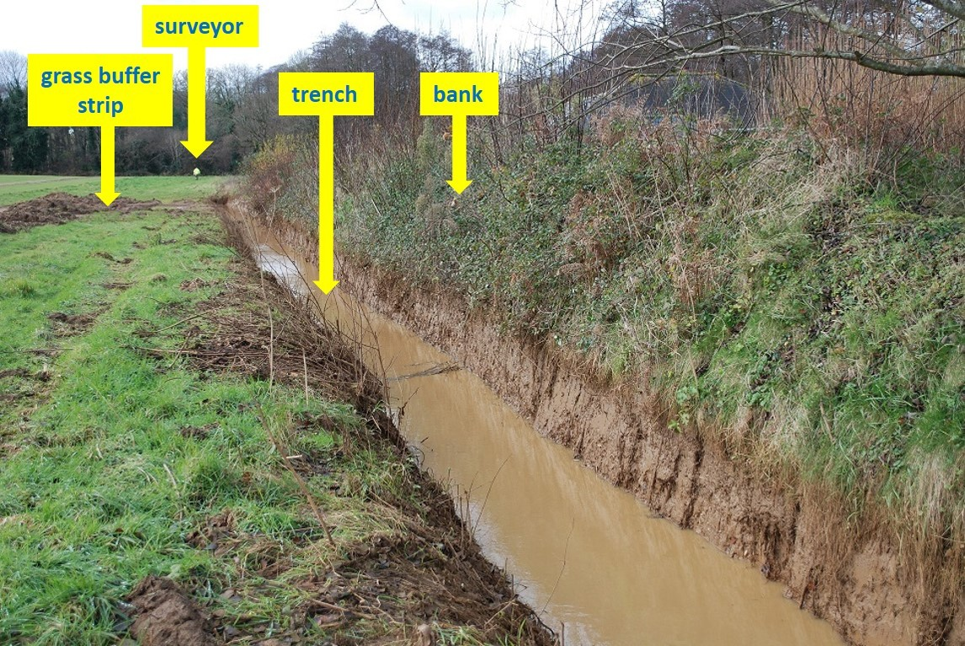
Trench, bank and grass buffer strip to protect house and garden (03/12/2012)

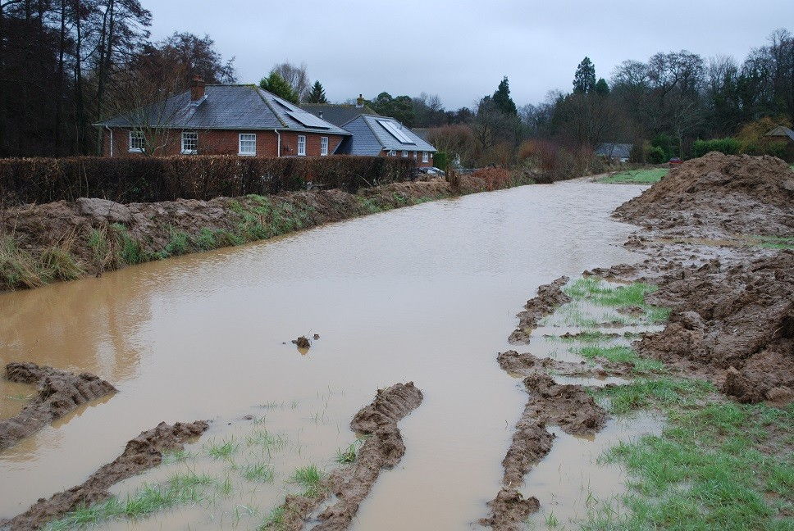

Trench full (29/01/2013

