Passport
to Employment
for Young People with
Special Educational Needs & Disabilities

This portfolio contains information about me and my skills and competencies.

Name Age Phone Email Address
YOUR NAME

MY STORY

Pictures of me

Hint: Add a picture here.

Who I am

Key strengths

What is important to me
MY STORY

What I want to do in the future

My referees and their contact information
MY STORY

Video about me

Hint: You can add a link to a video about you.

CV
Hint: You can attach
a link to your CV here.
You can also attach
a CV document below by clicking Add files.

Qualifications
EDUCATION / TRAINING

Completion date
Qualifications
School or college

Education and training courses

Start date and
end date
Training programme or training course name
School, college or training company

WORK EXPERIENCE

Certificates and diplomas

Hint: You can list certificates such as the Food Hygiene Safety Certificate.

Completed Certificate or diploma name
School, college or training company

Hint: Remember to list on- the-job training, summer jobs and work placements. You can include paid or unpaid and full-time or part-time work.

Dates of Employment
Company name Description of my tasks

WORK EXPERIENCE

Further information about my work
WORK EXPERIENCE

Video

Hint: You can add a link to a video about you
at work.

Pictures of my work

Hint: Add a picture here.

Things I have done

Hint: You can include things you have done at school, at work or a work placement, during your on-the-job training or in your home or community.

Tasks I can do well at work
SKILLS AND COMPETENCIES

Tasks I especially enjoy doing at work

Things I have done that make me proud
Hint: You can include any accomplishments you are proud of, for example diplomas, awards and positive feedback you have received from supervisors, co-workers
and customers. Consider all your life experiences.

SKILLS AND COMPETENCIES

My experience of working with others

Hint: You can describe your experience of team work at school or in the workplace or in your free time.

Practical skills

Hint: You can list skills such as cooking and repairing a car.

Languages

Equipment, tools and technology I can use, and my computer skills

Video

Hint: You can add a link to a video that shows you doing things you are good at.

Pictures of things I can do well

Hint: Add a picture here.
SKILLS AND COMPETENCIES

My interests

Hint: You can include here your career interests and personal interests.

My experience of working with others
My time management style
Hint: You can describe how you manage your time during your working day. You can also include here
punctuality, attendance, task management and meeting deadlines.
INTERESTS

In my free-time I like to

In my community I am active in
Hint: You can list any youth groups, social clubs or organizations or sports teams and your participation in them.

Video

Hint:You can add a link to a video about you and your interests here.

Pictures of my interests

Hint: Add a picture here.
INTERESTS

I need support in the following tasks in the workplace
ADDITIONAL SUPPORT NEEDS

I would like my additional support needs to be taken into account in the following way in the workplace
ADDITIONAL SUPPORT NEEDS

This guide was produced by the SENEL partners who would like to thank all the young people and their employers who so generously shared their stories with us.

The Partnership

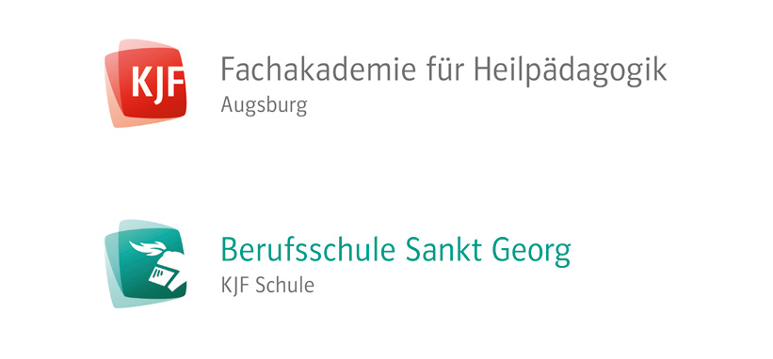

Disclaimer
The European Commission support for the production of this publication does not constitute an endorsement of the contents which reflects the views only of the authors, and the Commission cannot be held responsible for any use which may be made of the information contained therein.

