Questionnaire Data
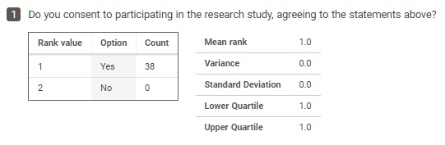

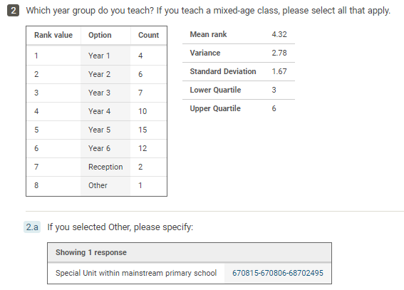

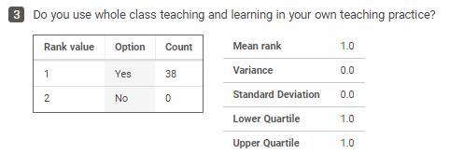

Mean score: 1.97
Standard deviation: 1.01

Note: ‘Rank value’ records the order in which score options were presented for participants to select from. ‘Option’ corresponds to the scores participants could select on a scale between -3 (unbeneficial) and 3 (beneficial). ‘Count’ indicates how many respondents selected each score option.

See coded questionnaire responses

See coded questionnaire responses
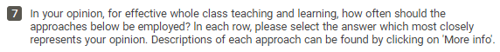

See coded questionnaire responses
See coded questionnaire responses

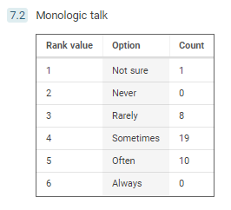
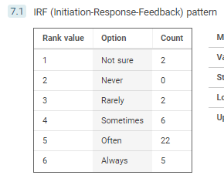

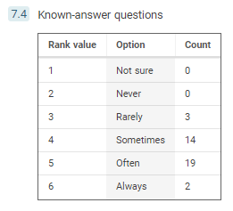
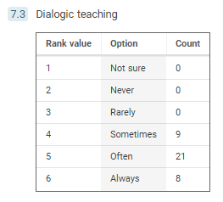

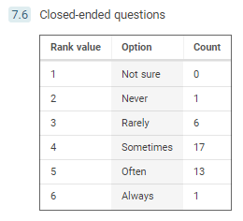
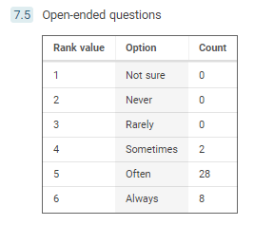

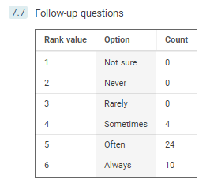

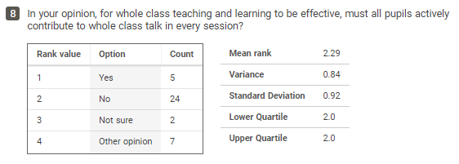

See questionnaire analysis and coding

See questionnaire analysis and coding

See questionnaire analysis and coding

Questionnaire Analysis and Coding

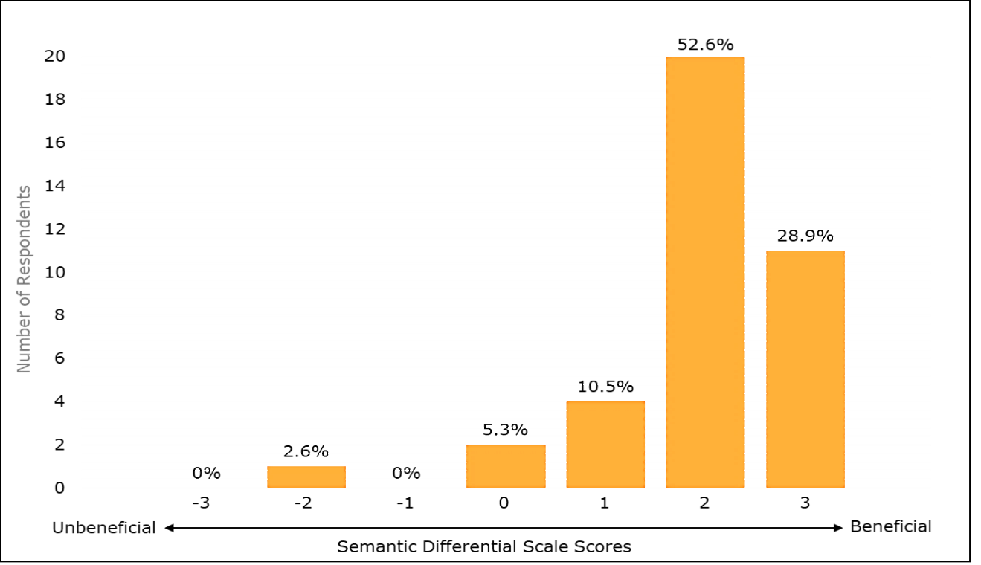
20

11

4
2
1

Figure 1: A vertical bar chart presenting primary teachers’ scores regarding the extent to which whole-class teaching and learning is beneficial or unbeneficial for children’s learning.
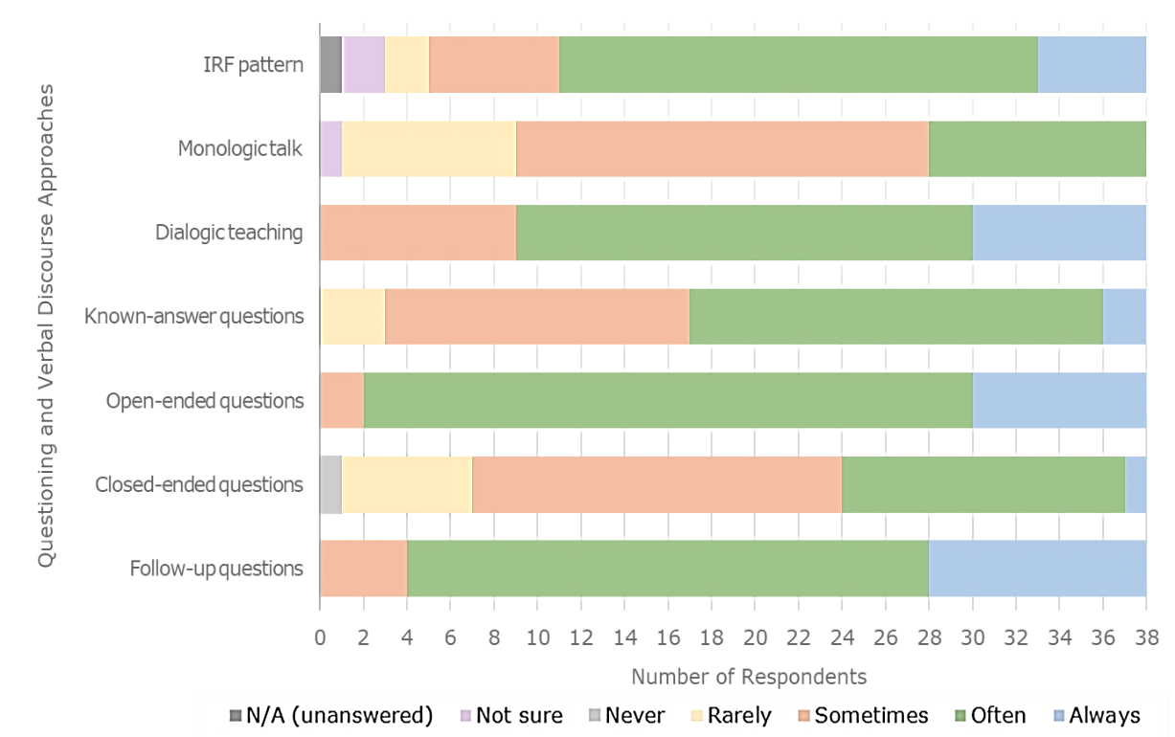

Figure 2: A stacked horizontal bar chart presenting primary teachers’ perceptions of how frequently approaches to questioning and verbal discourse should be utilised within effective whole-class practice.
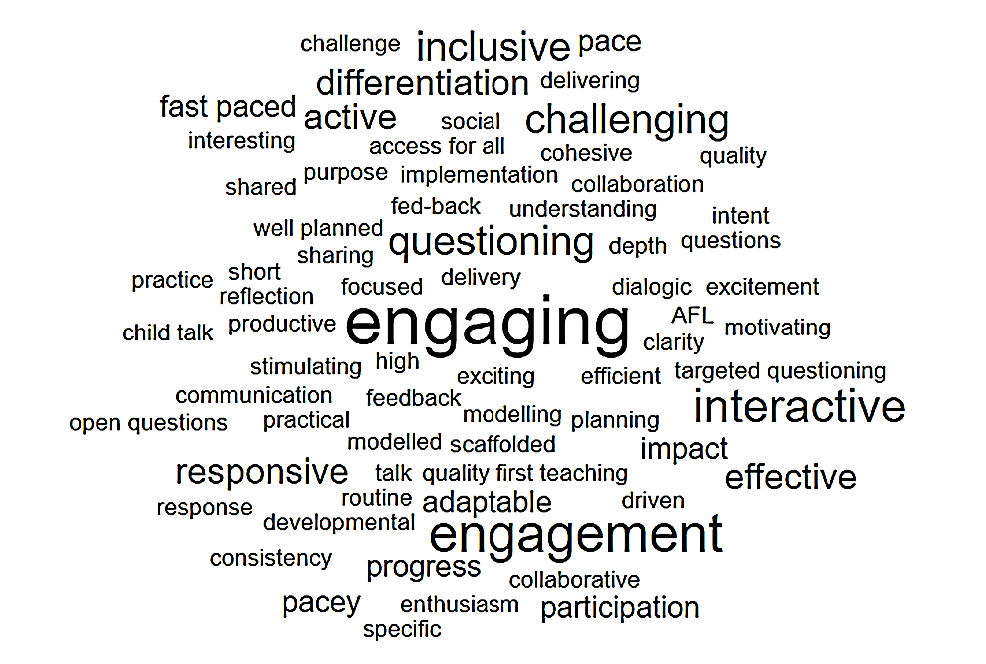

Figure 3: A visual representation depicting words perceived by primary teachers to best describe effective whole-class teaching and learning, with words sized according to frequency of response.

Coding: Benefits of Whole-class Teaching and Learning

Questionnaire Response (Question 5) | Inductive Coding
Learning from each other, supported by peers to understand and receive feedback. Teacher can observe understanding across a larger group | Peer Learning Assessment Opportunities
You know that all children are accessing the lessons, which are differentiated. Children are also able to demonstrate their knowledge by then working together, or have their understanding boosted by the support of peers. | Inclusion  Peer learning
Whole class getting the same input and therefore being able to achieve the same. | Collective Progress
The benefits of any approach are dependent on the quality of the skills of the person using it. Some potential advantages include equity of experience ensuring all children receive the same messages, sense of a shared learning experience, learning from each other, | Collective Progress  Peer Learning
All children are taught the same concepts and you can progress the class together. | Collective Progress
The peer discussion, peer scaffolding, whole class sharing of ideas. | Quality of Verbal Discourse  Peer Learning  Collective Progress
Ability for call and respond, chn to hear peer ideas, increased opportunities for AfL. | Quality of Verbal Discourse  Peer Learning  Assessment Opportunities
Children get to hear scaffolded answers no matter what their ability. All children have the opportunity to reach for the sky. When I have taught low ability groups before they have struggled with motivation as 'what is the point'. This way all children know what is expected. Also if you are always giving the lower children 'low' stuff no wonder they panic when it comes to exams and test | Peer Learning  Inclusion  Collective Progress
It encourages the quieter children to take part with confidence when having whole class discussions. makes it easier to identify children who are struggling. | Social Development  Assessment Opportunities
All children are given the same opportunity to access learning | Inclusion
Children of all abilities can learn from each other; LA children can model their responses from the HA children. Also, when the MA/HA struggle with a concept, we can bring them back using the same or similar strategies used by the LA. | Peer Learning  Addressing Misconceptions  Collective Progress
All abilities are challenged. High expectations are shared. Lower attainers learn from higher attainers. Curriculum content can be taught more readily. | Collective Progress  Classroom Management  Peer Learning  Convenience
Easier for the teacher to teach all 30 children at once | Convenience
Sharing of ideas, opportunities to learn from each other, learning to listen and take responsibility in a large group | Peer Learning  Social Development
You can take everyone with you - learn from others / higher expectations. | Collective progress  Peer Learning  Classroom Management
all chn receive the same information, not repetitive, ease of delivery for the teacher. | Collective Progress  Convenience
Saves time for the teacher having to explain to many different students individually. Makes sure that the concept is taught in student speak and can be punctuated with examples that might make them learn on different levels. | Effective Use of Time  Collective Progress
Time efficient, children able to share and gain ideas with/from each other and teacher, general formative assessment of learning and pitch of teaching | Effective Use of Time  Peer Learning  Assessment Opportunities
Children are not limited by an adults' / previous adult's view of them. There is no limit on what they are told they are capable of what they are being asked to achieve. | Inclusion  Collective Progress
Children can bounce ideas off each other, children who are less confident can learn from others and share ideas. | Peer Learning  Social Development
Shared writing to develop children’s understanding of where and how to improve text. Modelling of new concepts and sharing new language.  Opening discussion forums. | Collective Progress  Quality of Verbal Discourse
Children all receive the same information, children can share their ideas and understanding with other class members | Collective Progress  Peer Learning
effective use of time to deliver learning, particularly useful when tackling a new topic or something that all children are having difficulty with. This allows teachers to manage the pace of all learners and deliver high quality teaching that can address misconceptions quickly. I think this may have some time saving benefits for teachers. it makes resourcing easier. | Effective Use of Time  Addressing Misconceptions  Classroom Management  Convenience
Learning from peers, whole class teaching is often easier and less time consuming for teachers to organise. | Peer Learning  Convenience  Effective Use of Time
Level of discussion is better, improves working atmosphere when everyone doing the same task. Easier for the teacher to manage and help individuals. | Quality of Verbal Discourse  Classroom Management  Convenience
All learners have access to quality first teaching, no children feel 'left out' or 'different', teachers can focus on planning high quality lessons and task design rather than lots of grouped tasks. | Collective progress  Inclusion  Convenience
I think the main benefit is time. You can just do one input rather than having to repeat it to different groups. | Effective Use of Time
It prevents you repeating the same information over and over. Also those children that are less able can learn from listening to others in the class | Effective Use of Time  Peer Learning
That introductions especially of new content, can be heard in the same way by all children. Teaching based on feedback from previous lessons can also be taken on board by all | Collective Progress  Addressing Misconceptions
Children have the opportunities to work with each other, share ideas and embed their learning. | Peer Learning  Collective Progress
Ability to convey information to multiple pupils at one time. Student able to support each other. | Effective Use of Time  Peer Learning
Classroom organisation, one member of staff required and involvement of whole class (no risk of ‘us & them’ perception) are all big benefits. | Classroom Management  Convenience  Inclusion
Shared ideas. Other children can be excellent role models. The lower ability can be stretched and are given more access to all levels of learning. Higher ability children given the opportunity to 'be the teacher' and check their understanding through teaching. | Peer Learning  Collective Progress
All ch'n feel included. Can give the ch'n an input at a basic level then extend the higher ability ch'n and scaffold for the lower ability ch'n | Inclusion  Collective Progress
Ease for the teacher in planning and marking, and all students can access the same learning but scaffolded to their needs. | Convenience  Inclusion  Collective Progress
Social skills for children, learning from their peers as well as the teacher | Social Development  Peer Learning
Socialisation, help from other children to learn new concepts, learning to work collaboratively, learning to negotiate and compromise. Positive role models. | Social Development  Peer Learning
Behaviour, Learning as well as participation involvement improves | Classroom Management  Collective Progress

Table I: Coded questionnaire responses presenting primary teachers’ perceptions of the key benefits of whole-class teaching and learning.

Theme | Code | Frequency | Ranking
Social | Peer Learning | 20 | 1.5
 | Inclusion | 8 | 4
 | Social Development | 5 | 7
Educational | Collective Progress | 20 | 1.5
 | Assessment Opportunities | 4 | 8.5
 | Quality of Verbal Discourse | 4 | 8.5
 | Addressing Misconceptions | 3 | 10
Pragmatic | Effective Use of Time | 7 | 5
 | Convenience | 9 | 3
 | Classroom Management | 6 | 6
Total: |  | 86

Coding: Challenges of Whole-class Teaching and Learning

Questionnaire Response (Question 6) | Codes
Meeting all needs successfully can be challenging, ensuring SEND receive appropriate support | Differentiated Support
Due to the volume of lessons - even when teaching through a theme - a day can sometimes feel rushed and you find that there will be some children who you have barely interacted with. More often than not, it is those "middle" children who understand enough to get on with it, but don't work so quickly/aren't so secure with the task that they then need moving on to deepen and challenge their learning. This is more of a problem now during COVID times, as they are sat in rows (no collaborative working or small guided groups) and have to keep a distance where possible. | Challenging All Pupils
Children with special educational needs not being able to access whole class teaching to the same degree i.e children who have problems with focus, attention and concentration. Children's individual gaps in understanding and personal misconceptions could be missed. Higher ability children could have to listen to input they can already access and therefore are not consistently stretched. | Differentiated Support  Pupil Engagement  Individual Intervention  Challenging All Pupils
Some of the challenges are classroom management both in terms of keeping all on task but also keeping all engaged, ensuring pitch is suitable for all, use of questioning and other strategies to make it interactive rather than just teacher talking at pupils, a false sense of understanding where can be hard to gauge if they are ready to go and work independently | Classroom Management  Pupil Engagement  Appropriately Pitched Input  Active Pupil Participation  Effective Assessment
Some children progress quicker than others. | Differentiated Support  Challenging All Pupils
It is very difficult to support the SEN children, the lower ability children and to challenge the Higher ability. | Differentiated Support  Challenging All Pupils
Numbers, assisting LAP, SEND chn, chn not feeling heard (those shy chn who like to 'hide' during lessons. | Active Pupil Participation
Pushing greater depth children | Challenging All Pupils
One of the main challenges is the pace of the lesson for some children. | Appropriate Lesson Pace
Stretching higher ability whilst supporting those who struggle | Challenging All Pupils  Differentiated Support
Ensuring you have assessed each child efficiently for each lesson. For example, assessed when children are struggling and need further scaffolding as well as when children need to be moved on a challenged. | Effective Assessment  Differentiated Support  Challenging All Pupils
Differentiation in terms of recording and understanding. Behaviour challenges may disrupt more children. Being responsive to the needs of all children is more challenging. Ensuring all children have fully understood | Differentiated Support  Classroom Management
Not all pupils are able to access the whole class teaching because it is too difficult for them. And the opposite for those who find the content too easy. | Appropriately Pitched Input  Differentiated Support  Challenging All Pupils
Organisation, supporting the children that require specialist support, challenging all children effectively | Organisation  Classroom Management  Differentiated Support  Challenging All Pupils
Those at the very lower end need further assistance. | Differentiated Support
checking understanding, ensuring chn are engaged. | Effective Assessment  Pupil Engagement
Not all children are listening or participating. You can't always get everyone's attention. | Pupil Engagement  Active Pupil Participation
Differentiation, engagement, individual in-depth formative assessment, selective involvement | Differentiated Support  Pupil Engagement  Effective Assessment  Active Pupil Participation
Previous experiences of limited tasks will have negatively impacted children's views of themselves as learners. This needs to be overcome.  A history of being given limiting / low ability tasks will have resulted in a large range of skills and knowledge in higher year groups. | Pupil Engagement  Differentiated Support
Differentiation can be a problem when you have a huge range of abilities in one class, obviously this gap widens the older the children get so in Year 6 we are sometimes teaching children at a year1 level and children age appropriate and beyond. | Differentiated Support  Challenging All Pupils  Individual Intervention
Keeping and having all 30 pupils engaged at once.  Children can sometimes choose to coast or allow others, who feel more confident, to be more active.  It can make children who are unsure feel embarrassed about in front of peers. | Pupil Engagement  Active Pupil Participation
Differentiating for less able and more able | Differentiated Support
Children don't all learn at the same rate  Whole class teaching doesn't always cater for the prior knowledge and gaps of pupils. children who can already do this may become disengaged, bored or badly behaved. By whole class teaching, I tend to think that there is little differentiation in pace or task. personally I think there needs to be a mix of both whole class teaching and differentiated task teaching | Appropriately Pitched Input  Pupil Engagement  Classroom Management  Appropriate Lesson Pace  Differentiated Support
Sometimes holds higher attaining children back, especially if a teacher is not efficiently trained in moving their learning along. | Challenging All Pupils
Differentiation of tasks and starching the more able. | Differentiated Support  Challenging All Pupils
There are a minority of pupils that still struggle to access the learning, scaffolding and tasks still need differentiating at times. | Differentiated Support  Individual Intervention
Keeping all of your pupils focused and engaged. Children are not learning when they are not engaged and therefore no point in them being there. | Pupil Engagement
In larger class groups then behaviour in terms of listening and attention and concentration | Classroom Management  Pupil Engagement
The wide range of the ability of the children and their accessibility of the teaching | Differentiated Support  Appropriately Pitched Input
Ensure that the teaching is pitched to support the lower ability children whilst challenging the more able. | Appropriately Pitched Input  Differentiated Support  Challenging All Pupils
Ensuring all pupils are engaged and that the content is appropriate to all levels of ability/understanding. | Pupil Engagement  Appropriately Pitched Input
SEN needs and differentiation are much harder to manage. Individual targeting can be too. | Differentiated Support  Individual Intervention
Very challenging to differentiate. Particularly in maths. | Differentiated Support
A lot of differentiation and preparation involved  Some ch'n may feel lost in the lesson and if they are reluctant to ask for help, do not always get the support needed  Can be harder to engage a larger amount of ch'n who are working at different levels | Differentiated Support  Organisation  Pupil Engagement
Behaviour management and scaffolding resources so all children can access. | Classroom Management  Appropriately Pitched Input  Differentiated Support
Differentiation - wide variety of ability levels in class | Differentiated Support
Maintaining focus of all children, differentiating work to meet individual needs. Dealing with behavioural issues. | Pupil Engagement  Differentiated Support  Individual Intervention  Classroom Management
Teaching low level children and behaviour challenges | Differentiated Support  Classroom Management

Table II: Coded questionnaire responses presenting primary teachers’ perceptions of the key challenges of whole-class teaching and learning.

Theme | Code | Frequency | Ranking
Adaptive Teaching | Differentiated Support | 26 | 1
 | Challenging All Pupils | 13 | 2.5
 | Individual Intervention | 5 | 6.5
Lesson  Delivery | Appropriately Pitched Input | 6 | 5
 | Appropriate Lesson Pace | 2 | 9.5
 | Effective Assessment | 3 | 8
Pupil  Attitudes | Active Pupil Participation | 5 | 6.5
 | Pupil Engagement | 13 | 2.5
Pragmatic | Organisation | 2 | 9.5
 | Classroom Management | 8 | 4
Total: |  | 83

Coded Questionnaire Responses (Question 8)

‘Yes’ Questionnaire Responses | Codes
Active children engage more | Greater engagement
Passive learning is less effective than active learning | More effective
Children need to ensure they have opportunities to speak about their learning whilst using subject accurate vocabulary. It also provides opportunity to assess children's understanding. | Use of vocabulary  Assessment opportunities
At least in some way, a thumbs up or nod of the head to show the teacher they have understood. | Evidence of understanding
It ensures that all children are engaging in the lessons. The talk won't be to the whole class but all children should be talking to a talk partner. | Greater engagement

Codes (‘Yes’) | Frequency | Ranking
Greater engagement | 2 | 1
More effective | 1 | 3.5
Use of vocabulary | 1 | 3.5
Assessment opportunities | 1 | 3.5
Evidence of understanding | 1 | 3.5
Total: | 6

‘No’ Questionnaire Responses | Codes
There are many ways of contributing - talk is only one of them | Other ways to contribute and evidence learning
It is necessary for most of the class to contribute to class discussions. Others learn by listening to their peers. | Active listening
Not all chn need to contribute to learn. | Not essential for learning
Some children don't like to draw attention to themselves. Some like to sit and absorb the infprmation - the important thing is knowing who these children are. | Individual needs  Active listening
Some pupils like to listen to other pupil's contributions. Just because they don't appear to be actively contributing does not mean they are not learning. | Active listening
Some children struggle greatly with engaging with the lesson verbally, however, they can absorb everything that has been said by others and transfer this into their activity. | Active listening  Other ways to contribute and evidence learning
They can be involved in paired or group talk, not necessarily with the adult leading the class. However, different methods of responding, other than verbal need to be given for children who may not have good oracy skills. | Other ways to contribute and evidence learning  Importance of adaptive teaching
Children can benefit a lot from listening and being involved in the process. | Active listening
Some children feel very uncomfortable presenting information in whole class situations. Need to accommodate all children. | Individual needs  Importance of adaptive teaching
Some pupils listen but don't want to participate. Teacher needs to judge which ones are not talking because they are shy but still learning and which ones are not talking because they are on another planet of their own and not even taking in what's being said. | Active listening  Individual needs  Teacher’s judgement needed
Ideally children would all actively contribute but some children can take in teaching and therefore effectively learn without needing to actively take part in discussion, just by listening. | Active listening
Some children will listen and reflect on other children's ideas before they are happy to contribute themselves. They will demonstrate their understanding in other ways. | Active listening  Other ways to contribute and evidence learning
Sometimes they learn just as much by listening to their peers. | Active listening
It always feasible within the lesson  Sometimes children need to actively listen to help develop their understanding | Active listening
They may not know the answer and may need support from peers or teacher | Further support may be needed
As long as they are actively listening and you can tell this from their written work. | Active listening  Other ways to contribute and evidence learning
Depending on the size of the class, this is not always feasible, but it is important to encourage as many children as possible to contribute in some way. | Not always feasible
Children can still be engaged and listening without talking. It would also extend the time they are sat which is when you will start loosing them. | Active listening  Effective use of time
Sometimes, listening for short periods of time to promote learning can be just as effective | Active listening  Effective use of time
Some children do not enjoy contributing and the "fear" of this may lead to disengagement. The teacher needs to be aware of this and adapt accordingly. | Individual needs
Children learn by listening to other ideas | Active listening
Some ch'n are not always comfortable working this way. They can still engage and listen to ideas well but they do not have to always participate orally to learn if that gives them anxiety to do so. | Individual needs  Active listening
Listening to others can be beneficial to those who are uncertain in a topic or subject. | Active listening  Further support may be needed

Codes (‘No’) | Frequency |  | Ranking
Active listening | 17 |  | 1
Individual needs | 5 |  | 2.5
Other ways to contribute and evidence learning | 5 |  | 2.5
Effective use of time | 2 |  | 5
Further support may be needed | 2 |  | 5
Importance of adaptive teaching | 2 |  | 5
Teacher’s judgement needed | 1 |  | 8
Not always feasible | 1 |  | 8
Not essential for learning | 1 |  | 8
Total: | 36
‘Other Opinion’ Questionnaire Responses |  | Codes
I don't think they should all be expected to speak up within class, but I do think there should be a means for all children to actively engage with their learning, in order for it to be effective. No passive learning. Not all children will have the confidence - or ability - to verbalise their ideas, but should be made to feel a part of the learning process in the room so as to remain engaged. |  | Active engagement is key  Individual needs should be considered  All pupils should feel involved
Ideally yes, but this is sometimes difficult, particularly with children who have anxiety and don't like to answer questions - I still can check in on them during an activity to check they have understood and ask them questions about the task. By not asking students a range of questions, you can't fully assess the depth of their understanding. Some quieter pupils may go under the radar and end up with misconceptions that haven't been brought to light. |  | Difficult to achieve in practice  Individual needs should be considered  Questioning and responses are needed to assess learning  Teacher needs an awareness of pupils’ misconceptions
If by using strategies like partner talk or whole class responses then yes with a good number of individual responses too, but not in terms of a tick list approach where everyone gets asked a question as that may impact pace, purpose and engagement levels. It's not just being involved but the quality and type of engagement. |  | Quality of questioning and verbal discourse is more important
Some children do not feel confident to share their ideas but are still engaged with listening and reflecting. |  | Individual needs should be considered
all children must be engaged but not necessarily talking, opportunity to shine should be provided if knowledge based etc. as chn will be learning from listening. |  | Active engagement is key  Individual needs should be considered
In small classes yes When you only have a small number it encourages everyone to participate and also allows you to assess that they are listening |  | More feasible in smaller classes
In theory yes, in reality this can be difficult to achieve every time. Retention and reticence. So children understood but don’t retain well and cannot contribute as expected. Some do know, but remain quiet for a variety of reasons. |  | Difficult to achieve in practice
Codes (‘Other opinion’) | Frequency |  | Ranking
Individual needs should be considered | 4 |  | 1
Active engagement is key | 2 |  | 2.5
Difficult to achieve in practice | 2 |  | 2.5
All pupils should feel involved | 1 |  | 6
Questioning and responses are needed to assess learning | 1 |  | 6
Teacher needs an awareness of pupils’ misconceptions | 1 |  | 6
More feasible in smaller classes | 1 |  | 6
Quality of questioning and verbal discourse is more important | 1 |  | 6
Total: | 13

Teacher 1 Coded Interview Transcript
1
11
12
7
8
20
19
18
17
16
15
14
13
10
9
6
5
4
3
2
Teacher 1 Interview Transcript (Questions and Answers)  Thematic Coding Linked to Research Questions (Benefits, Challenges, and  Effective Practice Associated with Whole-class Teaching and Learning) | Inductive Coding | Theoretical Coding (Links to Literature)
Interviewer: I just wanted to check that you are happy and gave your consent to participate again just before we get started?  Teacher 1: Yep, absolutely. I do.  Interviewer: Wonderful. Ok, so what year group or year groups do you currently teach at the moment?  Teacher 1: I teach year 2.  Interviewer: Year 2, ok. Do you usually use whole class teaching and learning in your own practice and if you do, how and when do you usually use it?  Teacher 1: Yes, I’d say I use it quite a lot. I use it mostly for input and plenaries I would say. For example, at the beginning of a given lesson, let’s say maths, I would use whole class teaching and learning for roughly 15, 20 minutes. I like to get the children active during that time so I’ll get them on the carpet with whiteboards quite a lot or practical resources, and then I tend, not always but more often than not, to then send them off to be more independent and myself and my teaching assistant will work with a small group, and then at the end of the lesson we often will come back together to kind of share what we’ve learnt. So those are the times I’d say when I use whole class teaching and learning. I think the only exception and the only lesson where I use whole class teaching and learning for the whole lesson is phonics.  Interviewer: Right, ok. So that would constitute the entire lesson then?  21  22  Teacher 1: Yeah. Yeah, the entire 30-minute lesson, yeah.  23  Interviewer: Ok. I was going to ask as well, because it’s so current at the moment, has the emergence of the COVID-19 pandemic caused any changes to your whole class teaching and learning, how often or how you use it?  24  26  25  27  Teacher 1: I think at first it did. For example, when we went back to school in June, on the 1st of June, I was in a classroom with another fully qualified teacher and between us we had 11 children.  29  28  30  Interviewer: Ah wow, ok.  31  Teacher 1: Yeah and being able to break a group into 6 and obviously both being qualified teachers, the progress in that 6 weeks was enormous.  32  33  Interviewer: Hmm, yes.  34  Teacher 1: And that made me realise that small group teaching is, I believe, probably more effective than whole class teaching, small group teaching, but I just don’t think in a big class with 1 qualified teacher, it’s not, obviously it’s not practical or feasible really.  37  36  35  38  Interviewer: Yeah, was that quite different, that sort of small group, to your usual class size? Was that significantly smaller?  39  40  Teacher 1: Yeah. This was at a previous school. At the minute I have 22 in a class.  41  42  Interviewer: Right.  Teacher 1: At my previous school, I changed schools in September, at my previous school I had 30. So having 11 was significantly less and also obviously I’d normally have myself and a teaching assistant which was the same as I have at my current school, and possibly a 1-1 adult if there was a child in the class with an EHCP. Having 2 qualified adults and a smaller group obviously made a massive difference to be honest.  47  43  45  48  46  44  49  Interviewer: Well actually that links–  50  Teacher 1: I think–  51  Interviewer: Oh yes, go on. Sorry!  52  Teacher 1: Sorry you– no, no, you carry on. [both laugh]  53  Interviewer: That links really well to one of my later questions. I was going to ask if you find that whole-class teaching and learning has any influence on the use of your TAs or your support staff?  55  54  56  Teacher 1: Yeah, yeah, to be honest, during whole-class teaching and learning, best practice is to use your TA to support your behaviour management, so to have them in amongst the children at ground level if they’re, for example, sitting lower down on the carpet, and have them almost doing the behaviour management so you don’t have to interrupt your flow.  60  59  58  57  61  Interviewer: Right.  62  Teacher 1: I find that works quite well. Or just having them sitting next to perhaps children with additional needs or children that you know need extra support and kind of reiterating what you’re saying, kind of rephrasing questions in a way that they might better understand. So I think that’s best practice for use of a TA during whole class teaching. I would like to do more of... When I’m doing whole class teaching in an ideal world I would love to be able to have an additional adult that I can give a group of children to that I know are a little bit more needy, and teach similar to what I’m doing but just obviously in a smaller group you can scaffold it in a different way or slightly alter your input to that group and what you want their outcomes for the lesson to be. However, whilst TAs are amazing resources, I want to be really careful how I say this because I think TAs are absolutely amazing resources to have in schools…  66  67  65  64  63  69  68  70  71  72  73  74  Interviewer: Yes, absolutely.  75  Teacher 1: …but they’re not qualified teachers and unfortunately, I do think that in this, in the education sector, TAs are not valued enough and their personal development... There’s not a big focus on developing TAs’ subject knowledge or pedagogical knowledge as much as I think there should be. I’m not saying I wouldn’t trust my TA with a small group of children because she’s always working with small groups of children, but I think lots of studies have shown that sometimes lower ability, I hate that word but, struggling learners let’s say, don’t make as much progress as they should and lots of studies suggest that that’s because they are so often given to a TA and they get less teacher time than other children might. I think–  83  84  82  81  80  79  77  78  76  85  Interviewer: Hmm, would you– oh, you go on.  86  Teacher 1: Yeah, exactly and I do think that there’s a lot to be said for TAs needing to be valued more in schools and given the same... what’s the word I’m looking for... support as teachers are to develop.  88  87  89  Interviewer: Mmm. Yes, absolutely. Brilliant, ok thank you. I was going to ask a little bit about the benefits and challenges of what you think whole class teaching and learning brings. In a broad sense, do you find it to be more beneficial of more challenging? I know that’s quite a broad question but when you use it in your own practice?  93  92  91  90  Teacher 1: Yeah… yeah. I think it’s beneficial in terms of your time and energy. Often if you’ve got children working in groups or independently, there’s only one of you if that makes sense.  96  95  94  97  Interviewer: Mmm.  98  Teacher 1: So, there’s always going to be somebody that’s not getting your attention at that moment in time. So I think in that sense sometimes, timewise and energy-wise and resource-wise it’s often easier to just get everybody together to go over a concept. But I think, in terms of challenges, I think that children progress better as I said before when they’re working in smaller groups rather than up to 30. Listening to one teacher, I think they switch, they tend to switch off. Which is why it’s important that teachers are well trained in not, I don’t know what the technical term is but not a one-way conversation between you and a child, you and another child, you and another child, but the children bouncing off each other as well.  107  106  105  104  103  102  101  100  99  108  Interviewer: Sort of a dialogic talk?  109  Teacher 1: Exactly. That’s the word I’m looking for, a dialogue, yeah. So, I think it has challenges and benefits. I don’t know if that answers your question. [laughs]  110  111  112  Interviewer: No, absolutely. That’s brilliant. In link to that, how do you usually engage your pupils so you’re ensuring their effective learning in whole class teaching and learning? How would you go about engaging your pupils in that way?  114  115  113  116  Teacher 1: Yeah, I try and keep it as practical as possible, so I’m not afraid to bring whiteboards to the carpet. In maths we bring, each child or each pair has a maths pack and kind of, not being afraid to bring them, the maths packs, to the carpet. We also do a lot of bouncing between carpet and tables, carpet and tables.  119  118  117  Interviewer: Oh, yes.  120  121  Teacher 1: For example, in a writing task we might start a shared write on the carpet for 5, 10 minutes and then I’ll send them off to have a go independently and then after 5, 10 minutes we’ll come back and we’ll do a bit more of our shared write and then I’ll send them. So I think it’s hard for them to switch off and get bored because they’re up-down-up-down, it’s kind of constantly changing.  124  125  123  122  126  Interviewer: Mmm, yes. They’re constantly moving.  127  Teacher 1: If you, yeah. If you sit a group of children on the carpet for a 20, 25-minute input and they’re not grabbing their whiteboards quickly to show you something or they haven’t got their bead string in front of them or you’re not going to have a 10-minute break while they go and start their writing and then bring them back, I think the chances are a high percentage of those children will switch off.  131  132  130  129  128  133  Interviewer: Mmm, yes. I saw that quite a lot in one of my last placements. They used that ‘constantly moving’ and I found that it really did work. It had an effect, rather than just keeping them on the carpet for ages, definitely.  136  135  134  137  Teacher 1: Yeah.  138  Interviewer: Brilliant, thank you. One of the other ones I was going to ask is, in your opinion, what do you think is the most significant benefit of whole class teaching and learning? What’s the best thing that comes out of it?  140  141  139  142  Teacher 1: The best thing that comes out of it... I want to say children learning from each other. So sharing ideas and having the opportunity to partner talk and discuss and bounce ideas off you and off each other, but I think that you will only get that if the teacher has had training in that and that’s something they’ve had the opportunity to develop. I think I’d say that’s probably the biggest benefit is just having them all together and I think they just naturally kind of learn from each other as long as they are engaged.  145  144  143  147  146  148  149  Interviewer: Mhmm, yes I suppose that’s a key thing, keeping them engaged all the way through.  150  151  Teacher 1: Yeah.  152  Interviewer: Yes, and in your opinion what do you think is the most significant challenge of whole class teaching and learning? What do you think is the biggest challenge of it all?  154  153  155  Teacher 1: Differentiation. That’s where your TA is useful but if you’re without a TA, which some schools these days, some teachers these days often are, I think differentiation is a challenge when you’re doing whole class teaching and learning. How do you cater for those lowest children whilst still pushing your highs? Can you or is that something that comes, kind of later, when you ask them to be more independent? So I do think that is probably the biggest challenge.  159  160  158  157  156  161  Interviewer: Yes, absolutely. I’ve only got a couple more [questions to ask]. I was going to ask what you think are the most important principles, practices, learning theories, anything like that, that need to be ensured for whole class teaching and learning to actually be effective?  164  163  162  165  Teacher 1: See I’m... In a funny way, I did a lot of my training and when I was doing kind of like what you’re doing now, when I was doing studies and stuff, I did a lot of it on play-based learning in Key Stage 1.  166  167  168  Interviewer: Oh right, yes.  169  Teacher 1: Which obviously completely [goes] against whole class teaching and learning, it’s like that it’s kind of the complete opposite. Yeah I think that ideally, I would like Key Stage 1 children to do play-based learning or some form of continuous provision, but most schools don’t do that anymore. I think it’s a really important way of learning and I don’t think in this country that we do play-based learning for long enough.  170  171  172  173  174  175  Interviewer: Yes, it’s really interesting to hear that actually, to hear that opinion with your angle on it.  176  177  Teacher 1: I think a lot of people see it as just play and I’ve heard people that are quite high up in schools say it’s just play, which I think is completely incorrect and I’ve read a lot of studies and done a lot of research into it when I had to do stuff like what you’re doing and it’s so important. I know that doesn’t really help with the whole class teaching and learning…  181  178  180  179  182  Interviewer: It’s all really useful. [laughs] It’s really useful just to hear a contrasting perspective of, from a different angle, what might more effective.  184  183  185  Teacher 1: Ah.  186  Interviewer: Yes, that’s really useful. I was just going to ask, from some of the research I’ve been doing I’ve found that questioning and classroom talk seem to be two key elements to whole class teaching and learning. I wanted to see what ways you use questioning and talk to make sure that your whole class teaching and learning is effective, if you do use them?  191  190  189  188  187  192  Teacher 1: Yep, yep. I try and use... I think there is a place for simple answer questions if that makes sense, so, yes/no questions or questions where you’re looking for a specific answer, but I think you need to have a range and I use a lot of partner talk for more open-ended questions or perhaps recall questions linked to previous learning. I think children can learn a lot from partner talk as long as it’s modelled correctly, and it kind of creates that dialogue and then, when we talk about dialogues and I think I mentioned it earlier about not having like a… It shouldn’t be like one child just having a conversation with the teacher and then you move to another child. Trying to make that link, those links between children to get them to engage in discussion together.  197  196  195  193  194  199  198  200  201  202  Interviewer: Absolutely.  203  Teacher 1: From my experience, that’s a lot easier in Key Stage 2. You can model it and start to bring it in in Key Stage 1 and what I do a lot is, if somebody gives me, just for example in writing, somebody gives me an idea, then I will go back to the rest of the class and say ‘‘can we build on so-and-so’s idea with an adjective?’’ I try and get them to address each other rather than me, so I will try and facilitate them turning to that person and saying ‘‘you could use...’’ rather than like, saying to me ‘‘big’’, trying to get them to turn to kind of say to that partner ‘‘you could use the word big after...’’ whatever. If that makes sense.  210  208  209  206  207  205  204  211  Interviewer: Yes, absolutely. I think that is definitely really important.  212  Teacher 1: Yeah.  213  Interviewer: It’s one of those things you have to slowly integrate isn’t it? ...And introduce?  214  215  Teacher 1: Yeah, and then from my experience in Key Stage 2 it’s much, much easier to have classroom discussions where they’re addressing each other and you’re more like a facilitator. You see what I mean? And they’re leading the discussion.  218  217  216  219  Interviewer: That links really well to my last question actually. I was just going to ask, do you find that your pupils all actively contribute to whole class talk, and do you think that that’s really important for whole class teaching and learning to really be effective?  220  222  221  Teacher 1: I do think it’s quite important. In my current class, I’d say no, they don’t all actively contribute. There are some children who really don’t want to actively contribute and that’s where I try and use my TA. I think that, I’m coming from, obviously, a perspective now where we’ve just had such a long time off of school, and due to COVID, so I think that’s had a massive impact I’ve noticed on children’s social skills.  Interviewer: Do you think that impacts whole class teaching and learning then? Do you think there’s a link there?  Teacher 1: Yeah, I do. Yeah. They haven’t got the vocabulary. They haven’t developed those skills to be able to express their ideas.  Interviewer: Yes.  Teacher 1: I’ve changed schools so it’s hard to know, because I’ve changed schools in September, it’s hard to know whether it’s a new group of children in a new area, different demographic, or whether it’s linked to COVID but I think it probably is linked to COVID a little bit.  Interviewer: Mhmm. Yes, absolutely. Oh, well that’s it. That’s brilliant. Thank you. Do you have any more questions or comments or anything for me at all?  Teacher 1: No, I don’t think so. Just, good luck with it all.  Interviewer: Thank you so much. Right, I’ll stop the recording. | Frequent use of whole-class approaches  Input and plenaries  Pupil engagement  Active pupil participation  Variation in use of whole-class practice between subjects  Alternative contexts for teaching and learning  Classroom management  Effective deployment of support staff  Differentiated support  Need for professional development  Time interacting with the teacher  Effective use of time  Convenience  Convenience  Alternative contexts for teaching and learning  Need for professional development  Dialogic teaching  Active pupil participation  Classroom management  Pupil engagement  Pupil engagement  Active pupil participation  Social constructivism  Peer learning  Need for  professional development  Pupil engagement  Effective deployment of support staff  Differentiated support  Challenging all pupils  Alternative contexts for teaching and learning  Combining traditional and more recently established approaches to whole-class pedagogy  Dialogic teaching  Pupil-centred dialogue  Dependent on age of pupils  Teacher-as-facilitator  Pupil-centred dialogue  Dependent on age of pupils  Pupil-led verbal discourse  Active pupil participation  Effective deployment of support staff  Social development | Dawes (2018)  Kelly (2018)  Education Endowment Foundation (2018a)  Alexander (2013, p.4)  Mortimore et al. (1988)  Education Endowment Foundation (2018b)  Hughes (2017)  Willemsen et al. (2020, p.16)  Tyk (2014, pp.11-12)  Muijs and Reynolds (2018, pp.39-40)  Mercer and Dawes (2014, p.432)  Ritchhart (2015, p.212)  Alexander (2019)  Skidmore (2020, pp.27-37)  Hardman (2019, p.11)  Muijs and Reynolds (2018, pp.50-51)  Muijs and Reynolds (2018, pp.39-40)  Howe et al. (2019)  Willemsen et al. (2020, p.16)  Vygotsky (1978)  Alexander (2017, p.22)  Burns and Myhill (2004, p.36)  Florian and Beaton (2018)  Hardman (2019)  Burns and Myhill (2004, p.47)  O’Connor et al. (2017, p.5)  Education Endowment Foundation (2018a)  Eaude (2011, p.134)  Sherrington (2019, pp.29-30)  Medwell (2018, p.155)  Margutti and Drew (2014, p.443)  Mercer and Dawes (2014, p.432)  Ritchhart (2015, p.212)  Vygotsky (1978)  Howe et al. (2019)  Skidmore (2020, pp.27-37)  Kelly (2018)  Eaude (2011, p.135)  Muijs and Reynolds (2018, p.86)
242
241
239
240
238
234
236
237
235
233
232
231
230
228
229
227
226
225
224
223

Teacher 2 Coded Interview Summary
10
11
17
16
15
14
13
12
8
9
7
6
5
4
3
1
Teacher 2 Interview Summary (Questions and Answers)  Thematic Coding Linked to Research Questions (Benefits, Challenges, and  Effective Practice Associated with Whole-class Teaching and Learning) | Inductive Coding | Theoretical Coding (Links to Literature)
Can you confirm that you still give your consent to participate?
Consent to participate confirmed
What is your role in the school and which year group/s do you currently teach?
2
Year 4 class teacher
Do you use whole-class teaching and learning in your own practice? If yes, how and when do you usually use it?  ‘‘every lesson, every day, I use whole-class teaching’’ Particular use at the start of lessons so all children receive the same input and explanation. | Frequent use of whole-class approaches  Input | Alexander (2017)  Dawes (2018)
Has the emergence of the COVID-19 pandemic resulted in any changes to your whole-class teaching and learning, how often or how it’s utilised?  Uses whole-class teaching in school with key worker class.  Home learning: no live lessons but children are all receiving the same input. ‘‘... the work we’re setting on [Microsoft] Teams is whole-class teaching because they’re all getting the same thing.’’ | Same input offered to all pupils | Cox (2012, pp.43-44)  Alexander (2017, p.21)
Questions relevant to benefits and challenges
associated with whole-class teaching and learning
In a broad sense, do you find whole-class teaching and learning to be more beneficial or more challenging if/when used in your own practice?  19  18  20  Beneficial for the teacher in terms of planning a universal input for the children but perhaps not beneficial to all of the children. ‘‘The challenge is making sure every child understands what you mean.’’  22  21 | Convenience  Effective use of time  Differentiated support | Tyk (2014, pp.11-12)  Burns and Myhill (2004, p.47)  O’Connor et al. (2017, p.5)
If any, what would you say are the benefits of whole-class teaching and learning, for you as the teacher and/or for the pupils?  25  24  23  Greater ease and less time-consuming in terms of planning learning and resources and marking.  27  26 | Convenience  Effective use of time | Tyk (2014, pp.11-12)
If any, what would you say are the challenges of whole-class teaching and learning, for you as the teacher and/or for the pupils?  29  28  Making sure that all pupils understand the content of the lesson. ‘‘Some of them can’t keep up with the pace of a lesson’’  31  30 | Differentiated support  Appropriate lesson pace | Burns and Myhill (2004, p.47)  O’Connor et al. (2017, p.5)
In your opinion, what is the most significant benefit and challenge of whole-class teaching and learning?  33  32  Benefit: ease of planning for the teacher. Challenge: ‘‘making sure all the children are progressing and understanding.’’  34 | Convenience  Differentiated support  Challenging all pupils | Tyk (2014, pp.11-12)  Burns and Myhill (2004, p.47)  O’Connor et al. (2017, p.5)
Questions relevant to effective practice
associated with whole-class teaching and learning
What do you think are the important principles, practices or learning theories that need to be ensured for whole-class teaching and learning to be effective?  38  37  36  35  Assessment for learning whilst teaching. Questioning. Teachers’ awareness of which children understand, and which do not yet.  41  40  39 | Effective Assessment for Learning  Questioning | Department for Education (2011, p.12)
From some of the research I’ve been doing, I’ve found that questioning and classroom talk seem to be key elements of whole-class teaching and learning. In what ways do you use questioning and talk to ensure that whole-class teaching and learning is effective?  44  45  43  42  Questions posed as stimulus for independent work then addressed as a whole class – different answers shared. Questions prior to input can guide the learning so that it addresses misconceptions effectively. ‘‘I would use classroom talk every single lesson, multiple times.’’ ‘‘I would have a discussion with them nearly every lesson.’’  51  47  50  49  48  46 | Plenaries  Social constructivism  Peer learning  Addressing misconceptions  Frequent use of verbal discourse | Dawes (2018)  Vygotsky (1978)
How do you usually engage your pupils and ensure effective learning during whole-class teaching and learning?  53  52  Giving pupils ownership over what they would like to learn to successfully engage them. Whole-class research lessons are ‘‘really effective lessons.’’  54 | Pupil engagement  Dependent on lesson/curriculum content | Kelly (2018)  Dewey (1956)
Do you find that your pupils all actively contribute to whole-class talk? Do you think this is important for whole-class teaching and learning to be effective?  58  57  56  55  ‘‘Not all of them would come back to the whole-class discussion and answer questions or give their own ideas. Some of them are just too shy. Some of them are just reluctant to share their answer because they think they’re [going to] get it wrong.’’ It’s not necessarily detrimental to the lesson if not all children participate in whole-class verbal discourse as those who do can ‘‘steer the lessons’’ and the lesson keeps its direction/flow. However, in other ways it might be detrimental as some children go ‘‘under the radar’’ and ‘‘you can’t wait for them, all the time, to answer.’’  66  63  62  61  65  64  60  59 | Lack of active pupil participation in verbal discourse  Social development  Confidence  Appropriate lesson pace | Burns and Myhill (2004, p.47)  O’Connor et al. (2017, p.5)
Do you find whole-class teaching and learning has any influence of the use of the TA or support staff?  67  68  Participant reflected on their own current practice and possible changes. ‘‘If I was just teaching input at the start of the lesson, I think my TA is not necessarily needed, but then again, maybe I should be utilising her a little bit more to sit with the children who are the reluctant people to share answers, because usually when you get those ones that are reluctant to come back for feedback, if they’ve got an adult sitting next to them and they know they’ve already worked out the right answer or something on a whiteboard then they might have the confidence to share it if they know they’re [going to be] right.’’ ‘‘The time that I would usually teach a lesson to the whole class is time that my TA could be doing other things... interventions or something like that... but... I probably should be utilising her more so that the whole-class teaching is actually whole-class instead of just three quarters of the class.’’  80  79  78  77  76  74  75  71  72  73  70  69 | Effective deployment of support staff  Confidence  Social development  Active pupil participation  Time interacting with the teacher | Hughes (2017)  Education Endowment Foundation (2018b)
Do you have any further comments or questions?
81
No further questions.
Teacher 3 Coded Interview Summary
8
7
9
5
6
4
3
2
1
14
13
12
11
10
Teacher 3 Interview Summary (Questions and Answers)  Thematic Coding Linked to Research Questions (Benefits, Challenges, and  Effective Practice Associated with Whole-class Teaching and Learning) | Inductive Coding | Theoretical Coding (Links to Literature)
Can you confirm that you still give your consent to participate?
Consent to participate confirmed
What is your role in the school and which year group/s do you currently teach?
Deputy head teacher. Participant taught a Reception class during the Autumn term and also has a role in delivering Forest School sessions.
Do you use whole-class teaching and learning in your own practice? If yes, how and when do you usually use it?  Short whole-class input sessions used as part of teaching practice. | Input  Appropriate lesson pace | Dawes (2018)
Has the emergence of the COVID-19 pandemic resulted in any changes to your whole-class teaching and learning, how often or how it’s utilised?
No changes or effects relevant to whole-class teaching and learning identified in participant’s response.
Questions relevant to benefits and challenges
associated with whole-class teaching and learning
15
In a broad sense, do you find whole-class teaching and learning to be more beneficial or more challenging if/when used in your own practice?  17  16  ‘‘it can be beneficial because it allows you to share [...] information in one go rather than doing it repeating yourself several times’’ With older children through discussion and feedback, ‘‘it helps to address misconceptions before they’ve had time to embed’’ Highlighted the value of whole-class teaching for subjects in which discussion has a large role (e.g. RE) – ‘‘to get a whole-class discussion is really valuable’’  22  21  20  19  18 | Convenience  Effective use of time  Dependent on age of pupils  Addressing misconceptions  Dependent on curriculum area | Tyk (2014, pp.11-12)  Willemsen et al. (2020, p.16)
If any, what would you say are the benefits of whole-class teaching and learning, for you as the teacher and/or for the pupils?  25  24  23  Benefits for the teacher: ‘‘You only have to plan once. You’re only planning for one thing. You can disseminate a lot of information fairly quickly.’’  27  26 | Convenience  Delivery of concepts | Tyk (2014, pp.11-12)
If any, what would you say are the challenges of whole-class teaching and learning, for you as the teacher and/or for the pupils?  29  28  ‘‘for the teacher it can be hard to pitch it if you’ve got a very wide-ability class’’ It can be challenging to stretch the most capable children whilst supporting those who need it, knowing where to pitch a lesson and making adaptations so that all children can be successful. ‘‘Some children struggle to focus when all their peers are around them, and ... there’s a lot to listen to just from the teacher at the front they get side-tracked and lost’’  34  33  32  31  30 | Appropriate pitching  Challenging all pupils  Differentiated support  Pupil engagement | Burns and Myhill (2004, p.47)  O’Connor et al. (2017, p.5)  Margutti and Drew (2014)  Howe et al. (2019)
In your opinion, what is the most significant benefit and challenge of whole-class teaching and learning?  36  35  Benefit: The quality of discussion that can emerge from conversations involving a wider group of children. Challenge: Knowing where to pitch the content of the lesson.  39  38  37 | Quality of verbal discourse  Appropriate pitching | Willemsen et al. (2020, p.16)  Burns and Myhill (2004, p.47)
Questions relevant to effective practice
associated with whole-class teaching and learning
40
What do you think are the important principles, practices or learning theories that need to be ensured for whole-class teaching and learning to be effective?  41  43  42  Open-questions. Some use of Bloom’s Taxonomy as part of teaching practice. ‘‘Pitch the questions to get the best responses and [...] really make the children think.’’ Learning partners can be utilised across all of children’s learning.  47  45  46  44 | Open-ended questioning  Appropriate pitching (Bloom’s Taxonomy)  Peer learning | Ritchhart (2015, p.212)
From some of the research I’ve been doing, I’ve found that questioning and classroom talk seem to be key elements of whole-class teaching and learning. In what ways do you use questioning and talk to ensure that whole-class teaching and learning is effective?  51  49  50  48  Thinking time after asking questions and trying not to use hands-up. Targeted questioning can be used instead to stretch children effectively. Whole-class feedback can be preceded by pair talk to support children’s confidence and understanding. Use of a combination of teacher-led discussion and dialogue which mainly bounces between pupils. ABC strategy – peer responses can either agree, build on or challenge a previous answer and offer reasoning.  58  57  56  55  54  53  52 | Individual targeted intervention  Challenging all pupils  Differentiated support  Traditional and more recently established approaches  Dialogic teaching | Medwell (2018, p.155)  Jaeger (2019)
How do you usually engage your pupils and ensure effective learning during whole-class teaching and learning?  61  60  ‘‘Thinking about where they’re sat is important’’ for engagement, focus and differentiation through adult support (e.g. seating children closer to the front and nearer to an adult) and using pupils’ names can regain attention. Not using hands-up but instead a more direct questioning approach can encourage greater attentiveness.  65  64  63  62 | Classroom management  59  Pupil engagement  Differentiated support  Effective deployment of support staff | Hughes (2017)  Education Endowment Foundation (2018b)
Do you find that your pupils all actively contribute to whole-class talk? Do you think this is important for whole-class teaching and learning to be effective?  69  67  68  66  Some children are happier and more comfortable to contribute to whole-class talk than others. Trying to facilitate discussion in a ‘‘non-threatening way’’ can enable children to become more comfortable with engaging in whole-class talk. ‘‘there will always be some classes where, unless they’re directly asked, some children will not voluntarily seek to answer a question [...] but I think it’s getting more rare as it becomes embedded in practice.’’  75  74  73  72  71  70 | Social development  Community  Confidence  Embedded within practice | Alexander (2019)  Skidmore (2020, pp.27-37)
Do you find whole-class teaching and learning has any influence of the use of the TA or support staff?  77  76  Whole-class teaching and learning is ‘‘easier to manage in terms of additional adults sometimes because you can [...] deploy them to support specific children as needed.’’ However, additional support staff should clearly understand the objectives and key outcomes of the session and their role within the session, as having additional adults just sitting there is not effective.  82  81  80  78  79 | Classroom management  Effective deployment of support staff | Hughes (2017)  Education Endowment Foundation (2018b)
Do you have any further comments or questions?
83
No further questions.
Teacher 4 Coded Interview Summary
17
15
16
14
13
12
11
10
9
8
7
6
5
4
3
1
2
Teacher 4 Interview Summary (Questions and Answers)  Thematic Coding Linked to Research Questions (Benefits, Challenges, and  Effective Practice Associated with Whole-class Teaching and Learning) | Inductive Coding | Theoretical Coding (Links to Literature)
Can you confirm that you still give your consent to participate?

Consent to participate confirmed
What is your role in the school and which year group/s do you currently teach?
Deputy head teacher. Teacher 4 is responsible for covering classes across the primary age range and held intervention groups prior to the Covid-19 lockdown. Participant taught primarily in years 2 and 5 before Christmas.
Do you use whole-class teaching and learning in your own practice? If yes, how and when do you usually use it?  This depends on the particular content being taught, objectives and the prior knowledge of the children. These factors are used to decide a suitable approach to teaching and learning. ‘‘It depends how familiar children are with the concepts, so if it’s something that’s really new to everybody, then I will do whole-class teaching.’’ ‘‘problem-solving or investigations, I would do as whole-class teaching’’ Teacher 4 sometimes uses a maths mastery approach, rooted in whole-class teaching. Participant teaches writing more often as a whole-class lesson. | Dependent on curriculum area and content  Dependent on pupils’ prior learning  Input | Dawes (2018)  Alexander (2017)
Has the emergence of the COVID-19 pandemic resulted in any changes to your whole-class teaching and learning, how often or how it’s utilised?
20
19
18
21
Participant has been able to go between bubbles as long as social distancing is carefully maintained, so stated that few effects or changes have been identified.
22
Questions relevant to benefits and challenges
associated with whole-class teaching and learning
23
In a broad sense, do you find whole-class teaching and learning to be more beneficial or more challenging if/when used in your own practice?  25  24  ‘‘I think about whether [whole-class teaching and learning] is appropriate or not before I actually start using it’’ ‘‘When I do use it, generally I’d say it’s beneficial’’ However, failure to carry out initial assessments beforehand or lack of awareness of children’s levels of understanding could result in children being bored or a lack of graduated scaffolding. ‘‘Where it’s used well, it’s beneficial’’  29  31  30  28  27  26 | Consideration of suitability  Effective assessment  Pupil engagement  Scaffolded support | O’Connor et al. (2017, p.5)  Department for Education (2011, p.12)
If any, what would you say are the benefits of whole-class teaching and learning, for you as the teacher and/or for the pupils?  33  32  ‘‘It makes planning and differentiation fairly easy. Everybody’s going through at the same pace often, although you can set challenges. I think of it as [...] a straight road but sometimes you have little swerves off [...] sometimes that’s an intervention or sometimes it’s a challenge.’’ It can also be useful for covering content/concepts for the first time or for concepts where children have numerous misconceptions which need to be addressed as a class.  36  39  38  37  35  34 | Convenience  Differentiated support  Challenging all pupils  Individual intervention  Addressing misconceptions | Tyk (2014, pp.11-12)  Dawes (2018)
If any, what would you say are the challenges of whole-class teaching and learning, for you as the teacher and/or for the pupils?  40  42  41  ‘‘managing the different rates of ability’’ and ensuring appropriate levels of challenge and support for all children. Ensuring that content/sessions are interesting. Teacher 4 highlighted that these challenges are present regardless of the curriculum area.  46  45  44  43 | Differentiated support  Challenging all pupils  Pupil engagement | Burns and Myhill (2004, p.47)
In your opinion, what is the most significant benefit and challenge of whole-class teaching and learning?  48  47  Benefit: ‘‘It’s a really efficient, effective way of introducing something for the first time.’’ ‘‘It’s an effective way of making sure children get good quality teaching.’’ Challenge: Pitching appropriately to keep everyone engaged at their level. Not holding most capable children back or leaving struggling children behind.  52  51  50  49 | Effective use of time  Input  High-quality teaching  Appropriate pitching | Dawes (2018)  Burns and Myhill (2004, p.47)
Questions relevant to effective practice
associated with whole-class teaching and learning
53
What do you think are the important principles, practices or learning theories that need to be ensured for whole-class teaching and learning to be effective?  56  55  54  Questioning is key in catering for different ability ranges whilst using whole-class teaching and learning. Questions and reasoning opportunities prepared need to be appropriate for learners across the ability range of the class. Effective whole-class teaching and learning depends largely on the responses offered by the children. The teacher’s feedback on the children’s responses also needs to be carefully considered. Peer talk is very valuable.  63  62  61  60  59  58  57 | Effective questioning  Organisation  Pupil-centred verbal discourse  Feedback  Peer learning | Muijs and Reynolds (2018)  Willemsen et al. (2020, p.16)  Eaude (2011, p.135)  Jaeger (2019)
From some of the research I’ve been doing, I’ve found that questioning and classroom talk seem to be key elements of whole-class teaching and learning. In what ways do you use questioning and talk to ensure that whole-class teaching and learning is effective?  66  64  65  68  67  Advocated active learning in which children are involved. ‘‘not just teaching from the front’’ Children need opportunities to discuss their thoughts and challenge each other. The teacher’s role here can be to listen in and assess children’s learning. Closed questions can be used for checking that children are understanding. ‘‘open questions to, to really drill down into their understanding so that children are then explaining their thinking to themselves, to each other, to the whole class’’ ‘‘Questions need to be layered’’ Highlighted the importance of responsive teaching.  777  76  75  74  73  72  71  70  69 | Active pupil participation  Dialogic teaching  Teacher-as-facilitator  Effective assessment  Combining open-ended and closed-ended questioning  Responsive teaching | Kelly (2018)  Howe et al. (2019)  Medwell (2018, p.155)
How do you usually engage your pupils and ensure effective learning during whole-class teaching and learning?
79
78
Pupils’ engagement and relevant strategies were discussed in other parts of the interview and so this question was purposefully omitted.
81
80
Do you find that your pupils all actively contribute to whole-class talk? Do you think this is important for whole-class teaching and learning to be effective?  84  83  82  Some children may not wish to contribute whilst others are keen to voice their opinions. This must be managed by the teacher. ‘‘I think it’s important that a teacher checks in with every child, so those children who are reluctant/shy to join in need an opportunity to speak, but it may not be to the whole class.’’ ‘‘with older children it’s much easier to manage a whole-class discussion than it is with younger children.’’ ‘‘older children can listen and sit for longer’’  87  88  86  85 | Confidence  Social development  Classroom management  Dependent on age of pupils | O’Conner et al. (2017)  Eaude (2011, p.135)  Grigg (2015, p.349)
Do you find whole-class teaching and learning has any influence of the use of the TA or support staff?  Participant was unsure at first. They then highlighted the importance of deploying the TA at all points during a lesson, although needing to be mindful of TAs potentially acting as a barrier between the teacher and pupils. | Effective deployment of support staff | Hughes (2017)  Education Endowment Foundation (2018a)
Do you have any further comments or questions?
Participant asked to confirm if they could email with any further comments or questions.
99
98
97
96
95
94
93
92
91
89
90

