2. MATERIAL AND METHODS
Study areas
The scoping review focused on coastal lagoons in countries within the Guinea Current Large Marine Ecosystem (GCLME). That is Senegal, Gambia, Guinea Bissau, Guinea, Sierra Leon, Liberia, Côte d'Ivoire, Ghana, Togo, Benin, and Nigeria, all interfacing with the Gulf of Guinea and the Atlantic Ocean (Figure …). For this study, a lagoon was defined as shallow coastal waterbody that is about 100 m from the sea, permanently or intermittently linked to the sea and characterised by tidal exchanges and fluxes (Refs). A total of 31 lagoons were included in the study, with the majority being in Ghana and Nigeria. A list of the lagoons included in the scoping reviews is presented in Table …
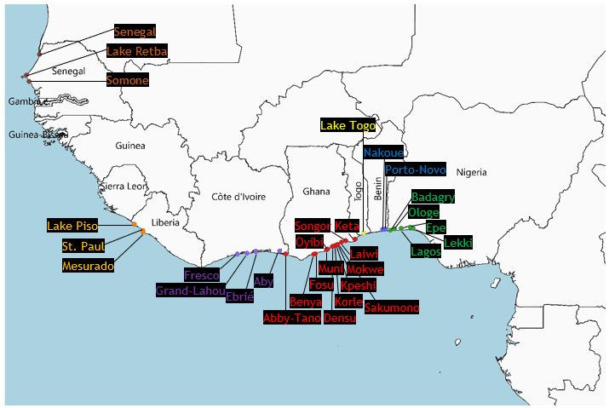
0
250
500
750 km

Figure…

Table …: List of coastal lagoons included in the scoping review.
Country | Lagoons | Total
Senegal | Somone, Senegal, Retba | 3
Liberia | Lake Piso, Mesurado, St. Paul lagoon | 3
Côte d'Ivoire | Grand Lahou, Ebrie, Aby, Fresco | 4
Ghana | Korle, Muni, Keta, Abby-Tano, Kpeshie, Fosu, Benya, Oyibi, Sakumono, Mokwe, Songor, Densu delta, Laiwi | 13
Togo | Lake Togo | 1
Benin | Lake Nakoue, Porto-Novo | 2
Nigeria | Lagos, Lekki, Epe, Badagry, Ologe | 5
Total |  | 31
*Gambia, Guinea-Bissau, and Guinea did not have lagoons that met the definition adopted for the study. No sources met the inclusion criteria for Sierra Leon.

Literature search and data collection
Sources of information for the review were obtained through a systematic literature search for relevant published and unpublished (gray) literature in web-based databases and search engines. These included Science Direct (Scopus), Web of Knowledge (ISI Web of Science), Google Scholar, and Google. Following the Joanna-Briggs scoping guidelines (Peters, 2017), the search string was based on generated keywords (English only) and synonyms for Population (lagoons or coastal lakes), Concept (Ecological state or management challenges), and Context (West Africa: Senegal, Gambia, Guinea Bissau, Guinea, Sierra Leon, Liberia, Côte d'Ivoire, Ghana, Togo, Benin, and Nigeria). The search was limited to the period between 1992 – 2021. After several iterations, the final search string used is as follows:
(“coastal lagoon*” OR “lagoon*” OR coast* lake* OR estuar*) AND (manage* OR challenge* OR problem* OR “manage* challenge*” OR “manage* problem*” OR “resource-use challenge*” OR “resource-use problem*” OR “govern* challenge*” OR “govern* problem*” OR drive* OR activit* OR pressure* OR change* OR impact* OR respon* OR action*) AND (Nigeria* OR Benin* OR Togo* OR Ghana* OR “Côte d'Ivoire” OR “Ivory Coast” OR Liberia* OR “Sierra Leon*” OR Guinea* OR “Guinea-Bissau” OR Gambia* OR Senegal* OR “West Africa*”)
The full search string could not be used in the Google search engines due to search string length limitations and unrecognition of Boolean operators within the google search engines. Thus, they were used as secondary search platforms for unpublished information on individual lagoons which lacked peer-reviewed literature. After removing duplicates, a total of 1,575 published articles were exported and reviewed at title and abstract level. The inclusion criteria were articles that addressed environmental, economic and/or social issues on any coastal lagoon in any of the West African Countries targeted by the study. The decision as to whether a coastal waterbody met our adopted typology of a lagoon or coastal lake and should or should not be included in the review was discussed and agreed by all authors. In addition, due to language proficiency of the reviewers, only articles that had English full text were included in the full text review. Relevant non-English articles with English abstracts were reviewed at abstract level only. A total of 171 articles met the inclusion criteria and were reviewed at full text.

Charting and evidence synthesis
The DAPSI(W)R(M) framework, as developed by Elliott et al. (2017) and used Mahrad et al. (2020) in a similar study of North African lagoon was adopted for the data extraction/charting stage. The framework is a widely adopted problem-structuring approach for analysing, understanding, and managing the causes and consequences of change in socio-ecological systems (Atkins et al., 2011; Gregory et al., 2013; Elliott et al., 2017; Mahrad et al., 2020). It structures environmental management problems as emerging from Driving forces of human needs, resulting in Actions which exert Pressures on natural resources, leading to State changes in the resources’ ability to deliver essential ecosystems services, which ultimately Impact human and ecological Wellbeing, and require technical and/or policy Responses/Measures to manage. In the charting process, information on each lagoon within the included literature that were related to each of the keywords in the framework were extracted and tabulated in a spreadsheet. The charting was conducted by one reviewer with supervision and agreement of two other reviewers. The results and discussions which follow are based on the extracted and tabulated information on each lagoon as agreed by all reviewers in the scoping exercise.

References
Peters MDJ, Godfrey C, McInerney P, Baldini Soares C, Khalil H, Parker D. (2011). Chapter 11: Scoping Reviews. In: Aromataris E, Munn Z (Editors). Joanna Briggs Institute Reviewer's Manual, JBI, 2017
Atkins, J.P., Burdon, D., Elliott, M., Gregory, A.J. (2011). Management of the marine environment: integrating ecosystem services and societal benefits with the DPSIR framework in a systems approach. Mar. Pollut. Bull. 62, 215–226.
Gregory, A.J., Atkins, J.P., Burdon, D., Elliott, M. (2013). A problem structuring method for ecosystem-based management: the DPSIR framework. Eur. J. Oper. Res. 227, 558–569.
El Mahrad, B., Abalansa, S., Newton, A., Icely, J. D., Snoussi, M., & Kacimi, I. (2020). Social-environmental analysis for the management of coastal lagoons in North Africa. Frontiers in Environmental Science, 8, 37.

