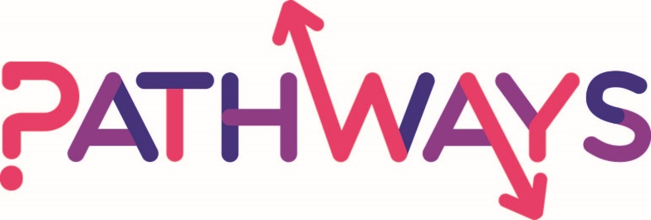

Title: Big Bang report
April 2018

Authors: Dr Toa Giroletti, Dr Ecem Karlidag-Dennis, Dr Meanu Bajwa-Patel

Table of Content
Introduction ………………………………………………………………………………………………………………………………3
Research Aims ………………………………………………………….……………………………………………………….3
Methods ……………………………………………………………………………………………………………………………………4
Data Analysis …………………………………………………………………………………………………………………………….4
Student Questionnaires ……………………………………………………………………………………………………..4
Stickers and Boards ……………………………………………………………………………………………………………9
Teacher Surveys ………………………………………………………..……………………………………………………..11
Describing the Event Using One Word ………………………………………………………………………………17
Student Interviews …….……………………………………………………………………………………………………..18
Conclusions …………………………………………………………………………………………………………………………….19
Recommendations ………………………………………………………………………………………………………………….21
Limitations ……………………………………………………………………………………………………………………………..21
Appendices ……………………………………………………………………………………………………………………………..22

Introduction
The Big Bang is a STEAM event in conjunction with 'Learn by Design' and Leicestershire University partners. As well as STEAM practitioners, local logistics business partners of the University of Northampton will be actively presenting at the event. The purpose is to increase the interest of the students (across Key Stages 3-5) in the STEAM subjects and careers.
The purpose of this report is to show whether the Big Bang event has increased the interest of the students in the STEAM subjects and careers, to get teachers’ feedback on whether it was useful for their students in terms of widening their horizons and closing the gap in social mobility and also recommendations for future events.
Research aims
The Big Bang event is part of National Outreach Collaborative Programme (NCOP). The overall purpose of NCOP is to boost young HE participation rates in England’s most disadvantaged areas can be broken down into the following outcomes:
1. Increase the application rate to HE of learners from identified schools in target wards in 2020;
2. Increase the proportion of learners in target schools with sufficient attainment at KS4 to successfully progress onto KS5 level study;
3. Increase number of female learners opting to study a STEM subject at HE by delivering activities aimed to raise awareness of women in science, technology, maths and industry;
4. Increase proportion of Level 2 BTEC learners that progress to BTEC Level 3 as an alternative route to HE;
5. Ensure that the key influencers (i.e. parents, carers, and teachers) receive communication around all activities offered by Pathways and wider information about options into HE;
Among these, the ones we focused on for the Big Bang events are the following:
RQ1) What is the output of the Big Bang event on the application to HE rate?
RQ2) What is the output of the Big Bang event on the number of female learners?
RQ3) What is the output of the Big Bang event on the understanding and knowledge of the pathways options to HE on the parents/carers of targeted cohort students?
Overall, the Big Bang helps to addresses the increase in the number of female learners opting to study a STEM subject at HE by delivering activities aimed to raise awareness of women in science, technology, maths and industry. Moreover, it helps to understand the knowledge students and teachers have on STEM and STEAM subjects.

Methods
A mixed methods approach was used in order to identify the impact of the event as well as teacher and students’ perspectives on the Big Bang. Questionnaires created by the ISII team were distributed to the students on the day, 20 students returned the questionnaires. An online survey was open from the day of the event to the end of April for teachers to complete. 30 teachers completed the survey. Qualitative data was collected from a sample of students during the day by conducting interviews. Moreover, there were two other methods applied to collect data during the day from students. “Stickers and Boards” which provided the team with quantitative data explaining the event’s impact on STEAM subjects. “Describing the Event in One Word” elicited the team with qualitative data showing whether students’ enjoy the event or not. Even in this case, we tried to capture any gender inequality by asking the students to write their names.

Data Analysis
Students’ questionnaires
Surveys created by the ISII team were given to the students on the day of the activity to be completed. It investigated the impact on the students of the Big Bang and how their propensity to study STEAM subjects has changed. In total, 20 students from secondary school returned the questionnaire, 39% males and 61% females.
The following figures show the interest of the students participating to the NCOP program with respect to the STEAM subjects, before and after the Big Bang. As the figures show, the students’ interest in STEAM subjects increased after the Big Bang.

Figure 1: Interested in studying any of the STEAM subjects before the Big Bang (%).

Figure 2: Big Bang improved your interest in STEAM subjects (%).

If we have a look at the differences between males and females, we acknowledge that the Big Bang had a similar impact on both groups. In fact, 89% of males and 93% of females answered that the Big Bang improved their interest in STEAM subjects. In particular, Table 1 shows the STEAM subjects to which the students are interested in after the Big Bang event. The students were able to select more than one option.

Table 1: interested in the STEAM subjects after the Big Bang (%).
Big Bang improved your interest in: | Science | Technology | Engineering | Arts | Mathematics | Not improved my interest in STEAM
Selected | 25.00 | 33.33 | 20.83 | 29.17 | 20.83 | 8.33
Not selected | 75.00 | 66.67 | 79.17 | 70.83 | 79.17 | 91.67
Total | 100.00 | 100.00 | 100.00 | 100.00 | 100.00 | 100.00
As the above table shows, the most selected subject is Technology, followed by Arts, Science, Engineering, and Mathematics. The following figure shows whether the participation to the Big Bang affected the students’ interest in STEAM career.
Figure 3: Big Bang affected interest in STEAM career (%).

Figure 3 shows that the interest in the STEAM career has increased after the Big Bang, in particular, 78% of males and 79% of females are more interested now. The below figure shows whether the Big Bang increased motivation to focus on the studies and achieve the students’ potential.
Figure 4: Big Bang increased motivation to focus on studies and achieve the students’ potential (%).

The results show that most of the students ‘strongly agree’ that the Big Bang has increased their motivation to focus on the studies and achieve the students’ potential (39%). Just a small portion (4%) disagree with it.
Figure 5: Big Bang increased my knowledge about how university systems works (%).

The above figure shows that 52% of the students participating think that the Big Bang have increased their knowledge about how university system works. However, the results show some discrepancy between males and females. In fact, 67% of the males and 43% of the females answered that Big Bang increased their knowledge about how university system works. This discrepancy lies on the girls’ indecision, in fact, 29% of the female students replied that they don’t know whether the Big Bang increased their knowledge about how university systems works, with respect to 11% of the male students.
Figure 6: One day I hope to go to University (%).

The above figure shows that most of the students strongly hope to go to university (65%), and 17% agree. In particular, the figures show that this result is driven by the female students. In fact, 44% of the males and 79% of the females strongly agree that one day they hope to go to university. Moreover, a significant percentage (9%) strongly disagree that they hope to go to university. In this case, this percentage is driven by the males (22%) with respect to females (0%).
Figure 7: Propensity to study sciences at GCSE (%).

Figure 7 shows the propensity to study sciences at GCSE, most of the students hope to study double science (41%), then single (23%), and finally triple (9%). However, a high percentage (27%) say that they do not know their propensity to study sciences at GCSE. It is interesting to notice that most of the females propend to study double science 38% and single 31%, whilst the majority of the males propend to study double science 38% and single 31%, and 33% don’t know.
Figure 8: Big Bang changed my thoughts about studying science at GCSE level.

Figure 8 shows that almost a third of the respondents haven’t changed their minds about studying science at GCSE level after the Big Bang (39%). Moreover, 30% find themselves more passionate and 26% less passionate about studying science at GCSE level.

Figure 9: After coming to the Big Bang I am more likely to investigate different routes into Higher Education (%).

The Big Bang event clearly had an impact on the students’ propensity to investigate different routes into Higher Education. In fact, Figure 9 shows that most of the students agree that after coming to the Big Bang they are more likely to investigate different routes into Higher Education. In particular, 56% of the males and 50% of the females agree that after coming to the Big Bang they are more likely to investigate different routes into Higher Education. Moreover, it seems that the Big Bang had a bigger impact on males than females, in fact, 14% of females disagree while only 0% of the males disagree that after coming to the Big Bang they are more likely to investigate different routes into Higher Education. On the contrary, only 7% of the females and 22% of the males do not know if, after coming to the Big bang, are more likely to investigate different routes into Higher Education.

Stickers and boards
As TBB event was so dynamic and hectic, research methods needed to suit, a series of boards with stickers were allocated around the building, with three titles ‘I have enjoyed today’s activity’, ‘Today has given me a clearer understanding of potential jobs in Science Technology Engineering Arts and Maths careers’, and ‘Today has given me a better understanding of the range of courses available in Science, Technology, Engineering, Arts, and Maths’. Under the sentences, we draw a Likert scale (from strongly disagree to strongly agree) and we ask the students to allocate the stickers according to their opinion (in Appendix Images 3, 4, and 5 of the final boards). The figures below show the final results of this exercise.

Figure 10: I have enjoyed today’s activity (%) [Girl=77; Boys=50].

Figure 11: Today has given me a better understanding of the range of courses available in Science, Technology, Engineering, Arts and Maths (%) [Girl=53; Boys=64].

Figure 12: Today has given me a clearer understanding of potential jobs in Science, Technology, Engineering, Arts and Maths careers (%) [Girl=53; Boys=64].

Figure 10 shows that the students enjoyed the Big Bang, more than 50% for both males and females strongly agree. Moreover, no one disagrees or strongly disagrees. Figure 11 shows that both girls and boys have a better understanding of the range of courses available in Science, Technology, Engineering, Arts, and Maths. However, while most of the females distributed their answers from ‘neither agree nor disagree’ and above, several males allocated their answers in strongly disagree (17%). With respect to the last question, both males and females strongly agree that ‘Today has given me a clearer understanding of potential jobs in Science, Technology, Engineering, Arts and Maths careers’. However, a high percentage of girls also strongly disagree that it happened (34%).

Teacher Surveys
Surveys (Appendix D) created by the ISII team were sent to the schools that attended the Big Bang event on 28th of February, 2018. The survey was available for the teachers during the event and after the event, and closed on 1st of April, 2018. The survey included eleven questions focusing directly on teachers’ experience at the Big Bang event. In total, thirty individuals returned the surveys. From these 30 teachers, 13 were secondary school and 17 were primary school teachers. This report summarises these thirty participants’ responses from the survey. Firstly, the Figure 13 below illustrates the breakdown of why the teacher brought their students to the Big Bang and the impact that they hoped to have on their students.
Figure 13: Why did the teachers bring their students to the Big Bang?
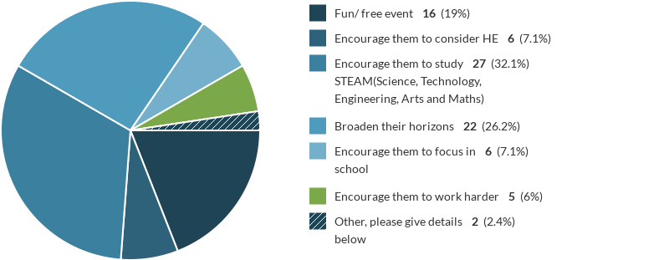

According to this chart, 32.1% of the participants stated that the reason why they brought their students to the Big Bang was to encourage them to study STEAM subjects. However, Higher Education did not seem to be their main motivation (7.1%).
72.4% of the participants were neutral when it comes to whether girls are keener on STEM subjects or not. Only 3.4% agreed that girls were more interest in STEM subjects compared to boys. However, when the same question asked in terms of boys being more interested in STEM subjects, 12% of the participants agreed that boys are keener on STEM subjects. Figures 14 and 15 below indicate the participants’ views on this.
Figure 14: Girls are keener on STEM (Science, Technology, Engineering, and Maths)
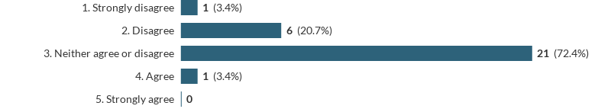

Figure 15: Boys are keener on STEM
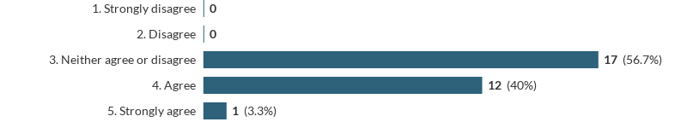

When looking at this result according to primary and secondary school teachers we can see some discrepancies, secondary school teachers strongly agreed (6.0%) that boys were keener on STEM whereas there were no primary school teachers who strongly agreed on this matter. Please see Appendices I and J to see both the primary school and secondary school teachers’ responses in detail. When we asked the same question but this time emphasising STEAM instead of STEM subjects, 7% of the participants agreed that the girls are more interested in STEAM subjects whereas when it was STEM only 1% of the participants strongly agreed that the girls were keener on STEM subjects (Figure 15). This can imply that adding Arts subject to the list might have made a difference (see: Figures 16 and 17)

Figure 16: Girls are keener on STEAM (Science, Technology, Engineering, Arts & Maths)
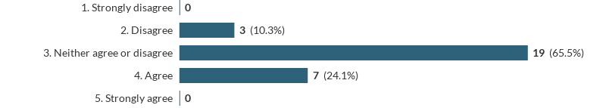
Figure 17: Boys are keener on STEAM
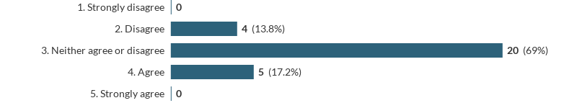It is safe to say that the majority of who responded to the question on STEAM subjects felt that the gender did not make a difference; 19% responded “neither agree or disagree” with girls being more interested in STEAM and, again 20% responded neither agree or disagree with boys being keener on STEAM subjects. When we investigate how this response was divided between secondary and primary sectors, we can see that there were not many primary or secondary school teachers who thought that girls or boys were necessarily keener on STEAM. Please see Appendices K and L for the charts indicating primary and secondary school teachers’ views on girls and boys studying STEAM subjects. This brings us to conclude the teachers do not see the gender as an issue for students’ choices on STEM or STEAM subject. Moreover, when the teachers were asked whether the gender is an issue or not, 56% stated that it was not and the reasons why students may or may not be interested in STEM or STEAM subjects varied (Figure 18).
Figure 18: Varies, gender isn’t the issue
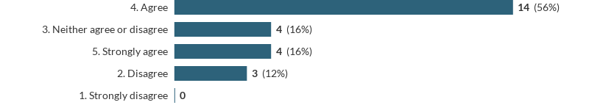
Both primary and secondary teacher seemed to agree on the fact that the gender was not an issue. Please see Appendix M to find primary and secondary school teachers’ responses. One of the questions in the survey focused on the social mobility in Higher Education. Teachers were asked to indicate whether events like the Big Bang can make any difference to close the gap among students in terms of socioeconomic strata. 56% of the participants reported that they believed events like this help to close the gap in Higher Education (Figure 19):
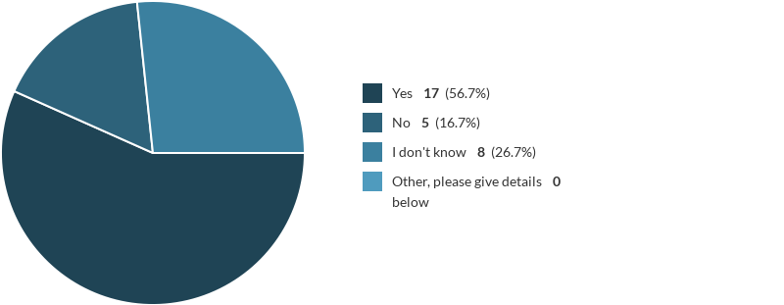
Figure 19: Closing the gap/Social mobility in Higher Education

Some of the teachers separately wrote in the comments section on the survey also that events like the Big Bang help widen students’ horizons and that students get the chance to experience new things and talk to relevant people. When students have this opportunity to talk to people in a field that they are interested in or they think they might be interested in this can have a big impact on their decision-making. It was also emphasised that the event was free of charge and the schools did not have to pay for transportation made a positive difference. However, some teachers also said that the event was “too busy to have any impact”. When we compared the different responses among primary and secondary school teachers, we see that 82 % of the primary school teachers and 72 % secondary school teachers said that the events like these help to social mobility. Please see Figure 20 below:

Figure 20: Closing the gap/Social mobility in Higher Education Primary vs. Secondary School Teachers
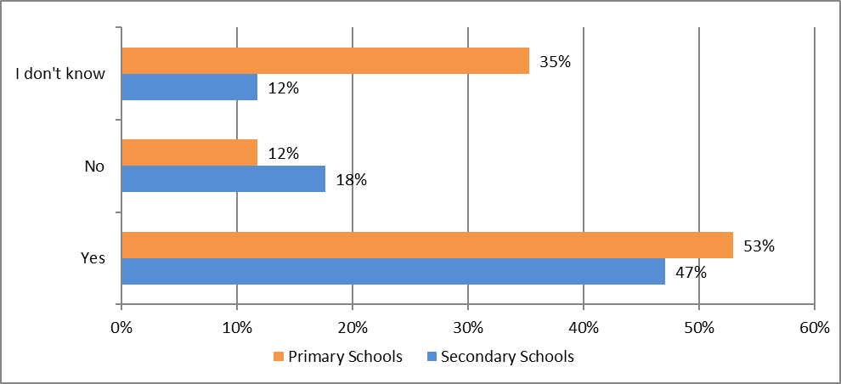
The last couple of questions addressed teachers’ knowledge on the Gatsby Career Benchmarks (Figure 21), the schools’ engagement team, and the booking platform (Figures 22 and 23).
Figure 21: Addressing the Gatsby Career Benchmarks

According to the responses, 65.5% of the participants did not know whether the Big Bang event enabled them to address Gatsby Career Benchmarks within the Ofsted framework or not, whilst only 24.1 % knew (Please see Appendix P for primary school and secondary school teachers’ responses).
Figure 22: Views on the learning resources by the Schools’ Engagement team
According to the figure 22 above, 51.7% of the participants reported that they found the learning resources provided by the Schools Engagement helpful, only 3.4 % reported that it was not helpful. 17.2% on the other hand, thought it was very helpful. It was mainly the primary school teachers who did not think the resources were helpful. Please see Appendix N to look at the different views on learning resources provided by the Schools’ Engagement team between primary and secondary school teachers. The figure 23 below indicates that 80% of the participants did not know about the ‘schools-engagement.com booking’ platform; only 20% said they were aware of it (Please also see Appendix O to see the primary and secondary school teachers’ responses).
Figure 23: Awareness of the Schools-Engagement.com Booking Platform
When it was asked in the online survey whether the participants would recommend the Big Bang to others, 26 of them stated that they would recommend the Big Bang to a colleague. Two of the participants said they would not and the other two were not sure. The participants who said they would not recommend it to others were primary school teachers. Considering the comments the teachers wrote, this chart (Figure 24) indicates that the primary school teachers found the event too crowded for their primary school students. When we look at the secondary school teachers’ responses, they all said they would strongly recommend it. Please see Figure 24 below to see the difference between primary and secondary school teachers’ responses:
Figure 24: Would you recommend TBB to a colleague? Primary School vs Secondary School Teachers
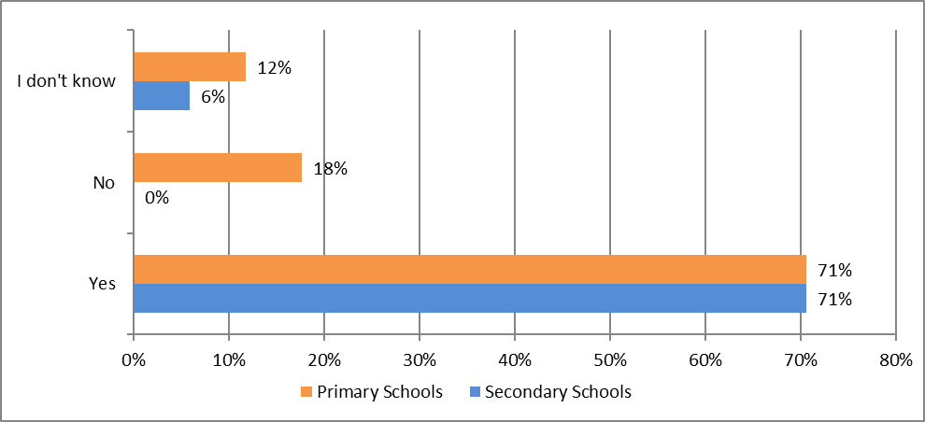

The suggestions the participants made are very significant and useful for the ISII, the Schools Engagement and Pathways teams to know what to improve for the future. The biggest issue for the participants was the business and crowdedness of the event; especially primary school teachers were not happy with the fact that their students’ time collided with the secondary school students.
The key aspect of the survey was the section on participants’ suggestions for improving the Big Bang. Apart from one, all 29 participants suggested an improvement for next year’s event. It was apparent from the participants’ suggestions that the biggest concern was the space issue. One of the primary school teachers reported that: “It was tricky to keep primary school children safe and together because if the number of attendees. Some of our children were pushed over by older students and a lot of our children couldn’t see the stands” (Participant 8). It was suggested by both the primary and secondary school teachers that the event should be separated into two days. For example, one primary school teacher stated to have “different days for Primary and Secondary” schools because “it got very crowded at times” (Participant 26). Another primary teacher, again, emphasised the space issue and said “more space for the guests to move around in. Silverstone was a huge venue and only part of it was used” (Participant 24). There were also a number of positive comments; one teacher reported that “the people on the stalls we did get to see were incredibly friendly and helpful” (Participant 30) and most teachers commented on the fact that there were a variety of stalls and activities.

Describing the Event in One Word: The Students’ Perspective
During the event, the ISII researcher put two A1 blank papers up to let students write their train of thoughts. This helped us get students’ views of the event. They reflected their thoughts on these big pieces of papers and gave them the freedom to write whatever they thought of the event. The boards acted as if they are leaving their comments on a website. Their writing then was analysed to see if they enjoyed the event or not. This activity also made the researchers realised that the students really enjoyed writing their thoughts by using coloured pens. They made a queue to have the chance to leave their feedback. When the researchers looked at the results, the overall comments students left were extremely positive. There were more than 100 students whom had written on the boards and they all noted that enjoyed the event. There were only a couple of students who commented on the crowdedness of the place, which was the main concern in teachers’ survey as well. Please see Image 1 and 2 in Appendices G and F to see some of the students’ comments.
The next section provides more detail on student perspectives by summarising the points from the interviews ISII team conducted during the Big Bang event.

Student Interviews
The ISII team conducted interviews during the event with some of the students. The team asked them about their views on the event, whether the event helped them with their career and Higher Education choices. In total there were 14 interviews; 4 of them were group interviews. There were key issues that were drawn from these interviews such as parental involvement and higher education awareness.
Parental involvement refers to the fact that the students who wished to attend a higher education institution or have already made up their mind about their career prospects had their parents’ influence on their decision-making. The students who were already eager to study STEM subjects or thinking about their careers mentioned that their parents (father or mother) were working in a STEM field. For example, one student said: “I want to be an engineer, my father is an engineer” (Student 1). This is also linked to students’ awareness of higher education. When the students asked if they were considering applying to any higher education institutes in future, some of the students who said yes often stated that their parents also attended universities so that is why they were already considering about it.
Some students stated that the event changed their minds about the STEM subjects. One student said “I thought science was a boring subject but here I have realised that it can be fun. It is more practical than I thought it was” (Student 9). The majority of the students stated that it was good to “find out about different fields” (Student 7 & 8). One of the students though said that this event has not changed his mind since he was “already interested in Science and want to study science at university” (Student 10). Some of the students also observed that they have done things in the Big Bang that they possibly would not do at school. One student stated: “Not like school where they just tell you what it’s like…here you get to be a part of it and get to experience stuff you’ve never experienced before, you come here and you can go and look at everything, everything, it’s all right here.” (Student 2). Another student also said that because of school “I thought science was just copying information from the board but here you see it is more than that” (Student 3). Commenting on the impact of the event, one of the students said “ I have changed my mind a bit, because I did want to work with animals but when I spoke to the lady about psychology I thought maybe I might, it sounds really cool” (Student 2). In one case, a student stated that the event changed his mind about studying computer since. Before the event he thought “it was pointless” but when he watched a video about it he thought “it was really cool” (Student 6). The majority of students reported that they enjoyed that the stalls were interactive and “not just people talk to you” (Student 2 & 5).
Overall, the majority of the students the ISII team interviewed reported that they enjoyed the event. They thought it was fun. The only improvement they suggested was once again the crowdedness of the place. One student said that the place was “cramped up” and younger students could not cope with the business of the event very well (Student 10). There were also some suggestions on several subjects of in the event. For example; a group of female students, who were interested in Arts subjects, said they would have liked to see more arts-based activities (Student 7, 8, 9 &10). Another student said he would like the event it if they had more animal-based jobs next year (Student 2).

Conclusions
The aim of this report was to examine and evaluate the teacher and students’ feedback from the Big Bang event. Our data collection from the event has shown that the Big Bang improved their interest in STEAM subjects and the students enjoyed the event. Moreover, both female and male students had a better understanding of the range of courses available in Science, Technology, Engineering, Arts and Maths after attending the event.
The results of the questionnaires show that the Big Bang had a similar impact on both males and females. In fact, a high percentage of both males and females answered that the Big Bang improved their interest in STEAM subjects (Figure 2). In particular, the most selected subject is Technology, followed by Arts, Science, Engineering, and Mathematics (Table 1). In general, the results show that, after the Big Bang, for the majority of the respondents:
- the interest in the STEAM career has increased (Figure 3).
- the students’ motivation to focus on the studies and achieve the students’ potential has increased (Figure 4).
- the knowledge about how university systems works (Figure 5), in particular for males with respect to females.
- the likelihood to investigate different routes into Higher Education has increased (Figure 9)
The results also show that most of the students strongly hope to go to university (Figure 6). In particular, the results are driven by the female students. In fact, 44% of the males and 79% of the females strongly agree that one day they hope to go to university. With respect to the propensity to study sciences at GCSE, the results of Figure 7 show that most of the students hope to study double science (41%), then single (23%), and finally triple (9%). Moreover, almost a third of the respondents haven’t changed their minds about studying science at GCSE level after the Big Bang and a third is more passionate about studying science (Figure 8).
The ‘stickers and board’ exercise shows that most of the students enjoyed the Big Bang, more than 50% for both males and females strongly agree (Figure 10). With respect to the range of courses available in STEAM, the results show that both girls and boys have a better understanding of the range of courses available (Figure 11). However, there is some discrepancy between males and females. In fact, most of the females distributed their answers from ‘neither agree nor disagree’ and above, several males allocated their answers in strongly disagree. With respect to the potential jobs in STEAM, both males and females strongly agree that the Big Bang has given them a clearer understanding of potential jobs (Figure 12).
Students’ writings on the boards demonstrated that the majority of the students found the event very interesting and useful. A small number of those who wrote on the boards suggested that the event was more crowded than it should have been. Moreover, this method of collecting data from students indicated the ISII team that students enjoy having the freedom to write their thoughts and leave their views on events.
One of the significant findings from this event was that, according to the surveys, the teachers did not think that gender is an issue when it comes to students’ preference of studying STEAM or STEM subjects. Saying that, it was also interesting to find out that 6.0% of the secondary school teachers strongly agreed that boys were keener on STEM. Furthermore, the teachers believed that events like Big Bang helped to increase social mobility and widen students’ horizons. The results from the surveys indicated that the teachers believed the Big Bang encouraged students’ to study STEAM subjects. The teachers reported that the event was a success in terms providing different variety of stalls and being cost free.
When the ISII team interviewed the students, they also feedback similarly on the event and stated that the stalls were interesting and they learned about different subjects. The students’ comments also emphasised the importance of their parents’ influence on their decision-making in terms of attending HE or studying STEAM subjects. However, some of the students also reported that attending the Big Bang changed their minds about studying some of the STEAM subjects like science. The event made them realise that science is more than just memorising formulas or copying notes; it is more practical and fun. The students made suggestions on including different subjects for the next event and lastly, the students like the teachers commented on the business of the event.

Recommendations
There was a great focus on the use of space both by students and teachers, both parties suggested that the space was not big enough and some students struggled to see the stalls. Therefore this issue could be examined more closely for next year’s event to avoid repeating the same problems. Also, some students stated their interest in arts and not seeing many art related stalls. Considering that STEAM includes arts as well as science subjects, it might be a consideration to have some art related stalls in next year’s event.

Limitations
The weather on the day (heavy snow) affected the schools’ arrival to Silverstone. Some schools cancelled attending the event last minute and some schools left early. Also, as previously stated business of the event caused some issues such as older children blocking younger children from the stalls, teachers finding difficult manage children and primary and secondary school students mixing. Since teachers were really busy trying to manage their students, they were not willing to do the surveys on the day, therefore, ISII team sent the surveys after the event. With the student interviews, there were problems with the noise. Since the place was really crowded and noisy, it made it difficult to hear the students’ voices from the recordings. Finally, not all the schools returned the student questionnaires to the ISII team.

Appendices
- Image 1: ‘Today has given me a better understanding of the range of courses available in Science, Technology, Engineering, Arts and Maths’.
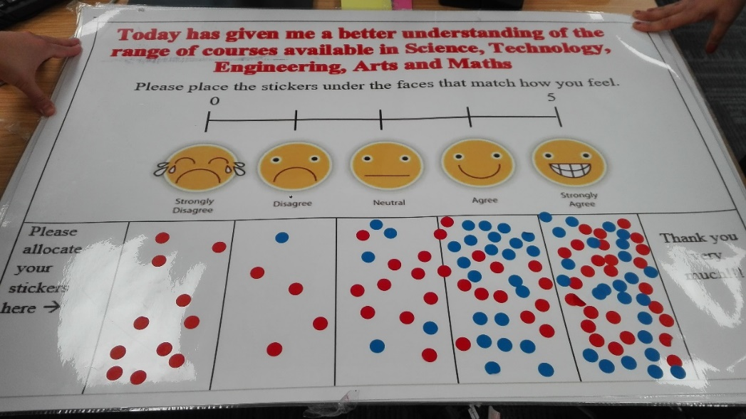
- Image 2: ‘I have enjoyed today’s activity’
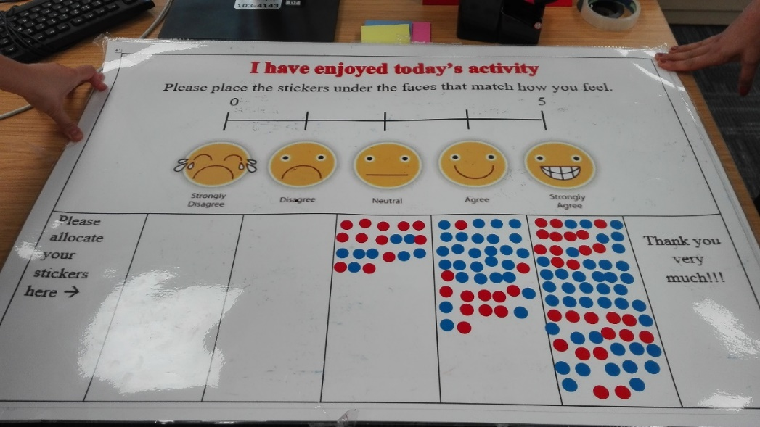
- Image 3: ‘Today has given me a clearer understanding of potential jobs in Science Technology Engineering Arts and Maths careers’
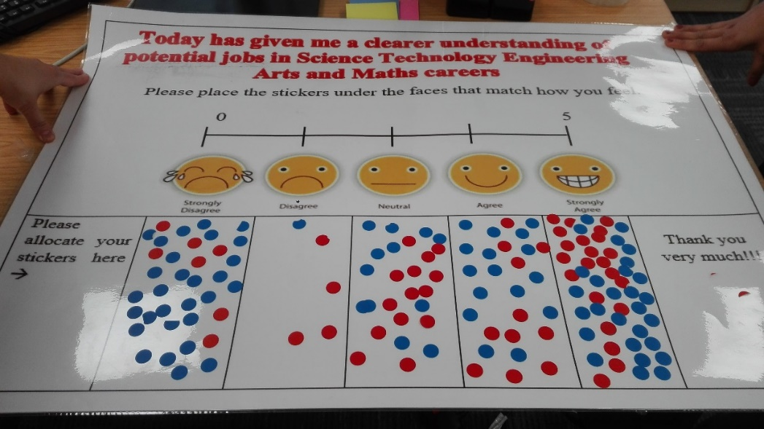
- Online teacher survey

Dear Teacher/Staff member
Please complete the questions below as part of our data collection to evaluate the Big Bang (TBB) event -28 February, 2018.
1. What school are you from?
2. Why have you bought students to TBB? / What impact are you hoping TBB will have on your students? (please tick all that apply)
Fun/ free event Encourage them to consider HE Encourage them to study STEAM Broaden their horizons Encourage them to focus in school Encourage them to work harder Other, please specify
Please indicate your views on the statements below (Likert scale)
Girls are keener on STEM
Boys are keener on STEM
Girls are keener on STEAM
Boys are keener on STEAM
Varies, gender isn’t the issue
3. Do you think events like this one make any difference when it comes to closing the gap (social mobility) in HE?
Yes No Don’t know Other, please specify
4. Has this opportunity enabled you to address the Gatsby Career Benchmarks, within the Ofsted framework?
Yes No No clue Other, please specify
5. What are your views on the learning resources provided by the Schools Engagement team?
V helpful, Helpful, Okay, Not helpful, Very unhelpful
6. Are you aware of the schools-engagement.com booking platform?
Yes No
7. Would you recommend TBB to a colleague?
8. Can you suggest one improvement to TBB event?
9. What is the best thing about TBB?
10. Would you come to TBB again?
11. I would be interested in being interviewed for the research on NCOP interventions and their impact please contact me on: email address:
………………………………………………………………………………………………..

- Consent Form

Interview consent form
Research being conducted for the Big Bang Event, as part of the social impact of the National Collaborative Outreach Programme (NCOP)
Today’s interview may be audio recorded to ensure that we are able to obtain the richest dataset from the session. The recordings will be transcribed for analysis; no one outside of the research team will have access to the transcriptions or recordings. The information will be used to compile a report for the about the social impact of the National Collaborative Outreach Programme activities and it may also be used in research seminars, conference presentations, proceedings, and publications taking account of all issues of confidentiality and protection of research participants.

The research team asserts their right to participate in any publication of the research findings in academic journals or other media which may ensue from the research.

You will not be named in the report; all findings will be anonymised. All data will be stored and used in accordance with the Data Protection Act 1988. Should you wish to access the findings from this research please contact a member of the research team at their email below.

If you are happy to take part in this research and proceed with the interview, please complete the section below.

Name:…………………………………………………Signature:……………….. Date…………………

Thank you for taking the time to support this research. If you have any queries following today’s interview, please do not hesitate to contact a member of the research team:

Dr Meanu Bajwa-Patel email: meanu.bajwa-patel@northampton.ac.uk
Dr Ecem Karlidag-Dennis email: ecem.karlidag-dennis@northampton.ac.uk

- Student Interview Questions
Gender: □ Female □ Male □ Transgender □ Prefer not to say
Year of school: __________________________ School/college: __________________________
Home post code or address: __________________________
Date of birth: __________________________

1.What do you think of the event?
2.What are your views on the STEAM (Science, Technology, Engineering, Arts and Maths) subjects?
3.Has this event changed your attitude towards any of these subjects?
4.Has this event had an impact on your career choices/decisions? Do you think you have more information about STEAM subjects now?
5.Do you think attending this event encourage you to consider going to university?

- Image 1: Student Feeback
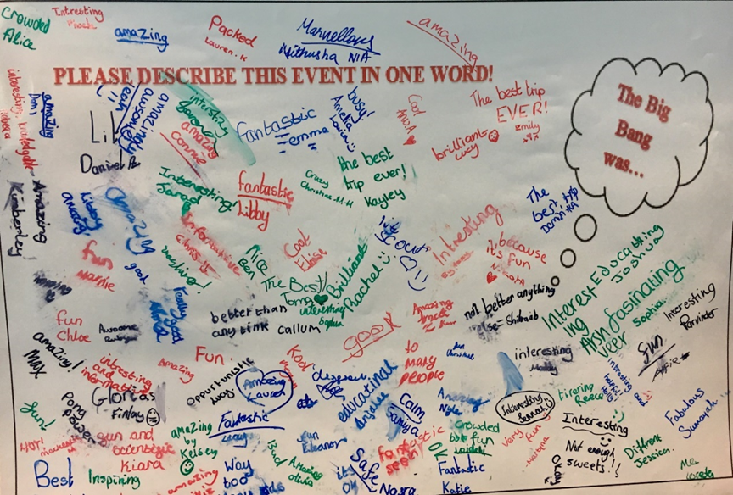

- Image 2: Student Feedback
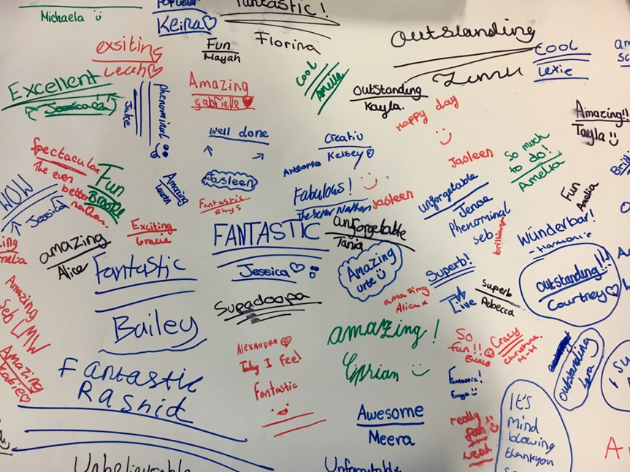

- Boys are keener on STEM- Primary School Teachers vs. Secondary School Teachers
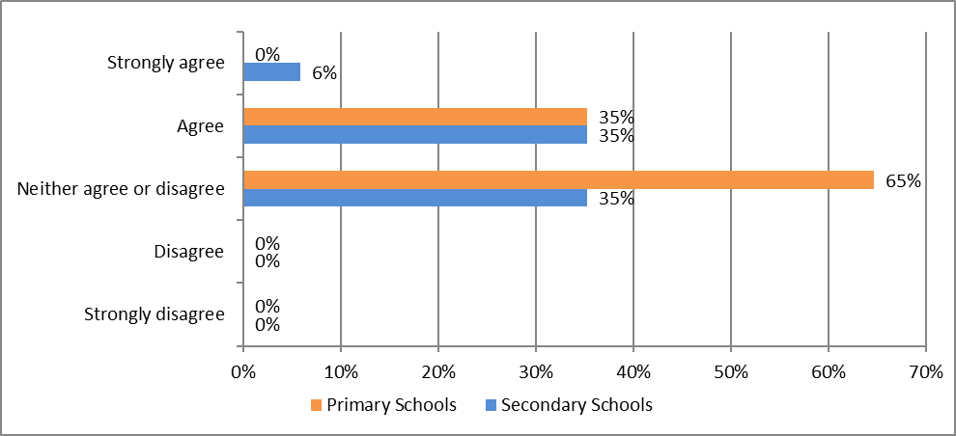

- Girls are keener on STEM- Primary School Teachers vs. Secondary School Teachers
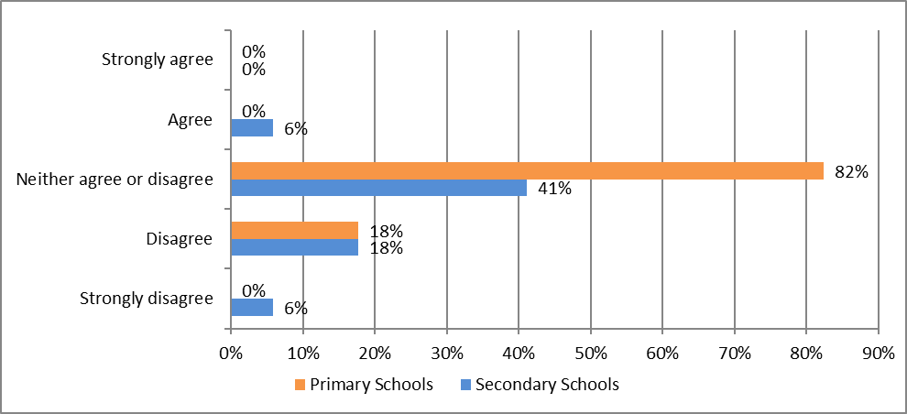
- Boys are keener on STEAM- Primary School Teachers vs. Secondary School Teachers
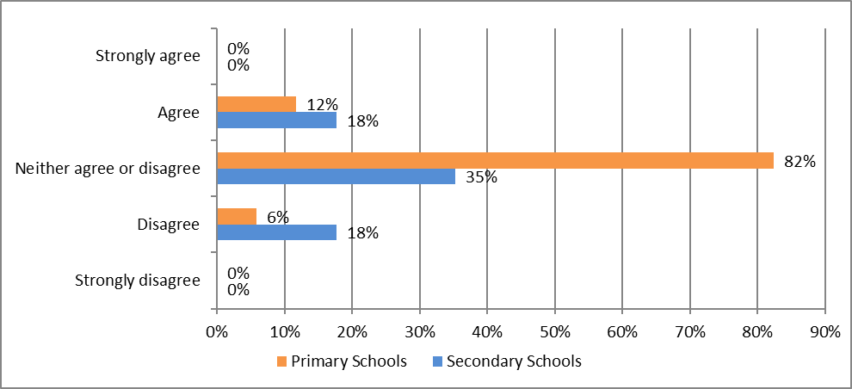
- Girls are keener on STEAM- Primary School Teachers vs. Secondary School Teachers
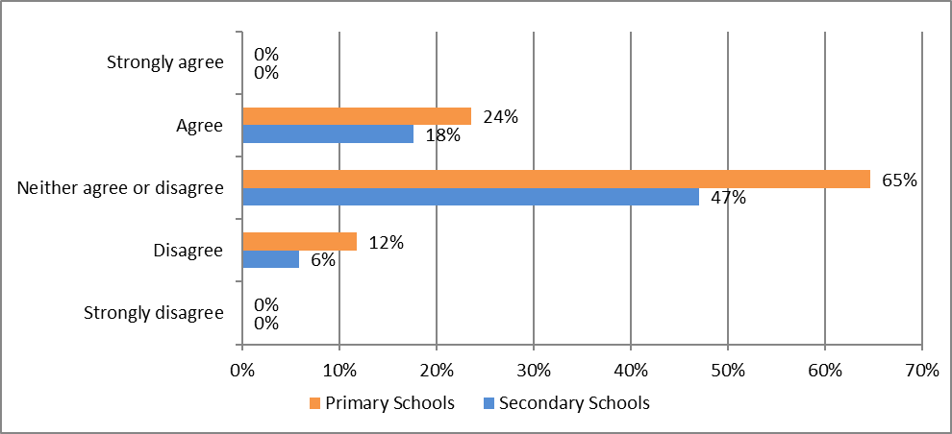

- Varies, gender isn’t the issue - Primary School Teachers vs. Secondary School Teachers
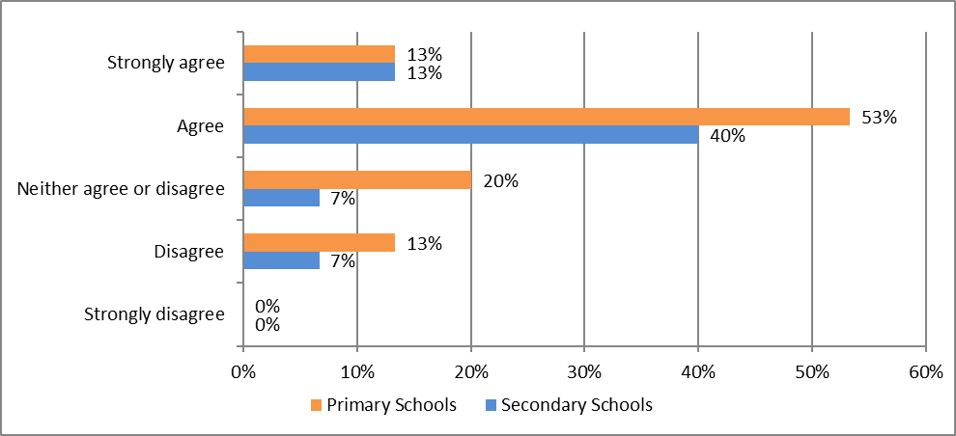
- What are your views on the learning resources provided by the Schools Engagement team? Primary vs Secondary School Teachers
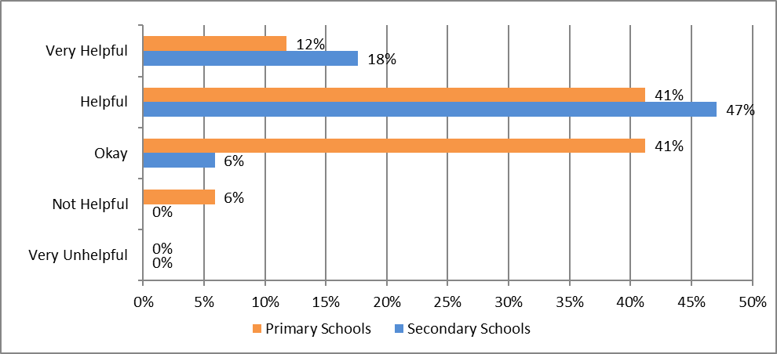
- Are you aware of the schools-engagement.com booking platform? Primary vs. Secondary School Teachers
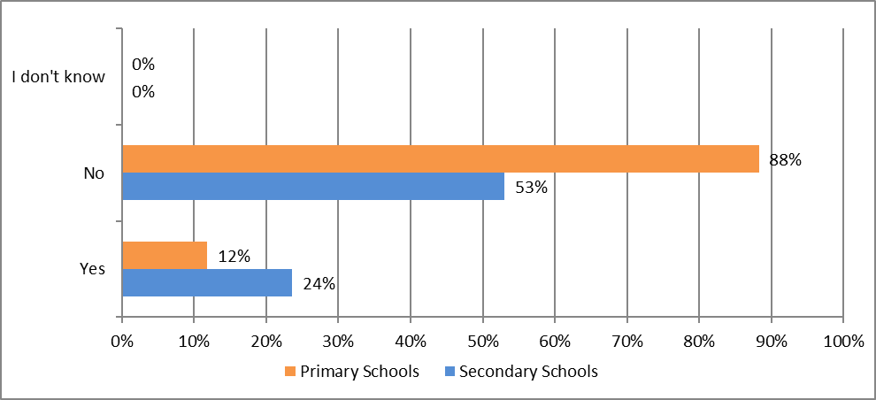
- Has this opportunity enabled you to address the Gatsby Career Benchmarks, within the Ofsted framework?
